**ONION (*ALLIUM CEPA*) PEEL AS AN ALTERNATIVE PAPER**

A Research paper presented to the faculty of

**KING THOMAS LEARNING ACADEMY INC.**

Malubago, Sipocot, Camarines Sur.

In partial fulfillment of the requirements for the

subject Practical Research II

**SCIENCE, TECHNOLOGY, ENGINEERING AND MATHEMATICS**

**ADOPTANTE, QUEENCY LEE M.**

**CHAN, JOSE MANUEL O.**

**CHUMACERA, ALDRIN N.**

**DE LA CRUZ, KRISJAN EIZER**

**MARASIGAN, ROSALINDA S.**

**PANUELOS, GABRIEL BRYAN**

**PAZ, WENCY ANGELO B.**

DECEMBER 2024

**CERTIFICATE OF APPROVAL**

The research paper attached hereto, titled “**ONION (ALLIUM CEPA) PEEL AS AN ALTERNATIVE PAPER**” prepared and submitted by **ADAPTANTE, QUEENCY LEE M., CHAN JOSE MANUEL O., CHUMACERA, ALDRIN N., DE LA CRUZ, KRISJAN EIZER, MARASIGAN, ROSALINDA S., PANUELOS, GABRIEL BRYAN, PAZ, WENCY ANGELO B**. In partial fulfillment of the requirements for the subject Practical Research II, is hereby accepted and approved by the Board of Panel whose signature appears below.

**MELANIE ROSE SJ. REYES**

Panel Member

**ROSELLE S. ESTOY**

Panel Member

**CHRISTINE JOY F. BACLAO**

Panel Member

**MA. MAJELLA C NIEVA**

Research Adviser

**MARY JOYCE N. RAMOS**

Assistant Principal – SHS Department

**ANGELI P. MORADA**

Academic Officer/Principal – SHS Department

**ACKNOWLEDGMENT**

The researchers would like to express their heartfelt gratitude to the following individuals for their constant and undying support, encouragement, assistance, and time for the accomplishment of this study.

**Ma’am Ma. Majella C. Nieva**, our Practical Research 2 teacher, who generously gave her time, effort, patience, knowledge, and assistance. Your expertise and encouragement were instrumental to the result of this study.

**Ma’am Angeli P. Morada**, Principal of the SHS Department for granting us the permission to conduct and gather data for this study inside King Thomas Learning Academy, Inc.

**Ma’am Mary Joyce N. Ramos**, Assistant Principal of the SHS Department for granting us the permission to conduct this study and for your willingness to assist and validate our paper for the success of this study.

**Ma’am Melanie Rose SJ. Reyes**, **Ma’am Roselle S. Estoy**, **Ma’am Christine Joy F. Baclao and Sir Clarence C. Borabien**, our Research Panelists for their guidance and mentorship throughout the conducting of research and defense. Without your feedback and expertise, this study will not be a success.

**Teachers**, **and Students,** our research respondents, who willingly participated during the data gathering process and for giving us your precious time to answer the given questionnaires.

**Almighty God**, thank you for being our guide through the ups and downs, for the blessings and strength you have given us. To God be the glory for the success of this study, we are deeply grateful for his hand on our work.

**Parents and friends**, for their love and willingness to help. Your financial and moral support has played a huge part in the success of this study.

**Q.L.M.A.**

**J.M.O.C.**

**A.N.C.**

**K.E.D.L.C.**

**R.S.M.**

**G.B.P.**

**W.A.B.P.**

**ONION (ALLIUM CEPA) PEEL AS AN ALTERNATIVE PAPER**

January 2025

**ABSTRACT**

This study aims to see the potential of onion (*Allium cepa*) peel as an alternative paper, focusing on its effectiveness and acceptability. The research aimed to assess the paper’s flexibility, durability, ink absorption, texture, color, and thickness, and analyze the significant relationship between the effectiveness and acceptability. Data was collected from King Thomas Learning Academy Inc. using a likert scale survey. The findings shows that the onion paper performed moderately in terms of flexibility and durability, with basic use but some limitations in consistency and ink absorption. The overall effectiveness was rated as neutral, indicating the need for more improvements in the process of making paper. In terms of acceptability, the paper was perceived positively for its unique texture and enough thickness, but there are some issues about its uneven color and rough edges. significant relationships were found between flexibility and texture, flexibility and color, and ink absorption and thickness, color, and texture. However, there is no significant relationship was found between durability and other properties. The findings concludes that the onion (*Allium cepa*) peel paper has the potential to be an alternative paper, but it needs more improvement, such as making the texture smooth, the color to be more consistent. For its current texture, the researchers recommend its use in making paper bags, as it has a strong structure suitable for this use. These improvements could help the paper become more useful and appealing to more people.

Keywords: *onion (Allium cepa) peel,* flexibility, durability, ink absorption, texture, color, thickness.

|  |  |
| --- | --- |
| **TABLE OF CONTENTS** | |
| **Preliminaries** | |
| Title Page | i. |
| Certificate of Approval | ii. |
| Acknowledgment | iii. |
| Abstract | v |
| Table of Contents | vi |
| List of Tables | viii |
| List of Figures | ix |
| List of Appendices | x |
| **Chapter I. Introduction** | 1 |
| Statement of the Problem | 2 |
| Objectives of the Study | 3 |
| Scope and Limitations | 3 |
| Significance of the Study | 4 |
| **Chapter II. Review of Related Literature and Studies** | 5 |
| Review of Related Literature | 5 |
| Review of Related Studies | 7 |
| Synthesis | 9 |
| Theoretical Paradigm | 12 |
| Conceptual Paradigm | 14 |
| Definition of Terms | 15 |
| Assumptions of the Study | 17 |
| Hypothesis | 17 |
| **Chapter III. Methodology** | 18 |
| Research Design | 18 |
| Research Setting | 18 |
| Respondents | 19 |
| Research Instrument | 19 |
| Validity and Reliability | 20 |
| Statistical Treatment | 20 |
| Data Gathering Procedure | 21 |
| **Chapter IV. Results and Discussion** | 24 |
| **Chapter V. Summary, Findings, and Conclusions** | 40 |
| **Problem 1.** | 41 |
| **Problem 2.** | 42 |
| **Problem 3.** | 45 |
| **Appendices** | xlix |

|  |  |  |
| --- | --- | --- |
|  | **LIST OF TABLES** |  |
| **Table 1** | Materials | 22 |
| **Table 2.1** | What is the level of effectiveness of the paper produced from onion (Allium cepa) peels in terms of Flexibility. | 25 |
| **Table 2.2** | What is the level of effectiveness of the paper produced from onion (Allium cepa) peels in terms of Durability. | 26 |
| **Table 2.3** | What is the level of effectiveness of the paper produced from onion (Allium cepa) peels in terms of Ink Absorption. | 28 |
| **Table 2.4** | Summary of the level of effectiveness of paper produced from onion (Allium cepa) peels. | 29 |
| **Table 3.1** | What is the level of acceptability of the paper produced from onion (*Allium cepa*) peels in terms of Texture. | 30 |
| **Table 3.2** | What is the level of acceptability of the paper produced from onion (*Allium cepa*) peels in terms of Color | 32 |
| **Table 3.3** | What is the level of acceptability of the paper produced from onion (*Allium cepa*) peels in terms of Thickness | 33 |
| **Table 3.4** | Summary of the level of Acceptability of paper produced from onion (*Allium cepa*) peels. | 34 |
| **Table 4.1** | Relationship Between the Level of Effectiveness and Acceptability of Onion (*Allium Cepa*) peel as an Alternative Paper based on flexibility. | 36 |
| **Table 4.2** | Relationship Between the Level of Effectiveness and Acceptability of Onion (*Allium Cepa*) peel as an Alternative Paper based on durability. | 37 |
| **Table 4.3** | Relationship Between the Level of Effectiveness and Acceptability of Onion (*Allium Cepa*) peel as an Alternative Paper based on ink absorption. | 38 |

|  |  |  |
| --- | --- | --- |
|  | **LIST OF FIGURES** |  |
| **Figure 1** | Theoretical Framework | 11 |
| **Figures 2** | Conceptual Framework | 13 |
|  |  |  |
|  |  |  |
|  |  |  |

|  |  |  |
| --- | --- | --- |
|  | **LIST OF APPENDICES** |  |
| **APPENDIX** |  | |
| **A** | References | l |
| **B** | Communication Letters | lii |
| **C** | Sample Questionnaire | lx |
| **D** | Statistical Computation | lxvi |
| **E** | Documentation | lxiii |
| **F** | Curriculum Vitae | lxxviii |

**CHAPTER I**

**INTRODUCTION**

Paper has been a fundamental tool for communication since ancient times. While the world is increasingly digital, the demand for paper remains strong and is expected to continue growing due to its versatility. Every year, 8 billion trees are cut down solely for paper production. Of these, 55% are used for packaging, 26% for printing and writing, 8% for sanitary products, 7% for newspapers, and the rest for other purposes. Research indicates that 24 trees are felled every minute globally (Neha Rajas et al., 2023).

In Central Asia, onions (Allium cepa) are a fragrant, edible bulb that is grown extensively. As a member of the Amaryllis family (Amaryllidaceae), it is closely related to leeks, garlic, and chives. It is the most widely grown species in the Allium genus and is commonly referred to as the bulb onion (Messiaen and Rouamba, 2004). Onions are a common cooking component in India and are the second most significant horticultural crop in the world, behind tomatoes (Celano et al., 2021).

Research has specifically shown that onion peels or skins are a rich source of bioactive chemicals (Osojnik Črnivec et al. 2021; Kumar et al. 2022). Applications for onion waste could be found in the fields of agriculture, industry, nutraceuticals, and cosmetics (Celano et al. 2021). One example is the conversion of onion waste into beneficial by-products with strong antioxidant qualities for use as a functional food additive (Roldán et al. 2008).

The use of onion skins in paper-making presents a promising solution to deforestation and its environmental consequences. This method offers a sustainable alternative, reducing the need to harvest trees and mitigating the associated environmental problems. Research suggests that handmade paper production contributes to a decrease in deforestation, ultimately leading to a reduction in environmental degradation. This eco-friendly approach has fueled the growth of handmade paper manufacturing. Handmade papers are highly versatile, allowing for creative and innovative designs, and can be used for both writing and printing. They also possess satisfactory strength and offer numerous environmental advantages (Neha Rajas et al., 2023).

This study demonstrated that incorporating onion skins into paper production mitigates deforestation by reducing the demand for wood pulp, decreases greenhouse gas emissions through minimized processing energy, and lessens water pollution by eliminating chemical bleaching agents, thereby contributing to a more sustainable and environmentally responsible paper industry.

**Statement of the Problem**

The study aimed to solve and answer the following question:

1. What is the level of effectiveness of the paper produced from onion (*Allium cepa*) peels in terms of:

a. Flexibility

b. Durability

c. Ink absorption

2. What is the level of acceptability of the paper produced. from onion (*Allium cepa*) peels in terms of:

a. Texture

b. Color

c. Thickness

3. Is there a significant relationship between the level of acceptability and effectiveness of the paper produced from onion (*Allium cepa*) peel.

**Objective of the Problem**

1. Determine the effectiveness of the paper produced from onion (*Allium cepa*) peel in terms of:

a. Flexibility

b. Durability

c. Ink absorption

2. Identify the level of acceptability of the paper produced from onion (*Allium cepa*) peel in terms of:

a. Texture

b. Color

c. Thickness

3. Analyze the significant relationship between the level of effectiveness and acceptability of the paper produced from onion (*Allium cepa*) peel.

**Scope and Limitations**

The study focused on creating writing paper from onion (Allium cepa) peel and will be conducted at King Thomas Learning Academy Inc.

However, it has several limitations. First, only the onion peel is used in the paper production, excluding the flesh of the onion. Additionally, the study had the participation of Grade 11 STEM 4-AMBER students from King Thomas Learning Academy Inc. The feedback on the paper was gathered using a Likert scale. The study did not cover the paper's suitability for use with printing devices or typewriters.

**Significance of the Study**

This research aims to make an alternative paper out of onion (*Allium cepa*) peel. It will also provide crucial information and knowledge regarding the chosen topic. This will be beneficial to the following:

**Department of Environment and Natural Resources (DENR).** The Department of Environment and Natural Resources (DENR) will benefit in this study, because it will help in promoting waste reduction and recycling initiatives.

**Department of Trade and Industry (DTI).** The Department of Trade and Industry (DTI) will benefit in this study by using onion peel as an alternative paper source aligns with the goals of exploring ways to reduce waste and utilize byproducts. Lead to the development of sustainable industries and practices within the agricultural sector.

**Paper Manufacturer.** The paper manufacturer will be benefited in terms of making different paper made out of onion (*Allium cepa*) peel. It is also eco-friendly which helps not to use too much wood.

**Student**. The student will benefit as they can experiment with different methods of processing onion peels, such as pulping, bleaching to optimize the production of paper. It can contribute to a more sustainable future by promoting resource conservation and reducing waste.

**Future researchers**. The future researcher will be benefited in terms of making their own study because this research serves as an inspiration for them to do other studies using onion peel. Future researchers may also improve their study which makes use of onion.

**CHAPTER II**

**REVIEW OF RELATED LITERATURE AND STUDIES**

In this chapter, the researchers included materials from published and unpublished articles and studies that were found to be connected to the present study which greatly helped the researchers to further elaborate the background of the study.

**Review of Related Literature**

According to the article from the Paper Mill Blog (2024), onion skin paper is celebrated for its thin, translucent quality and surprising strength, attributes achieved through high percentages of cotton fibers or chemically treated wood pulp. This approach not only strived to match the performance of traditional onion skin paper but also emphasized environmental benefits by reducing waste and utilizing an alternative, eco-friendly source. Clarify the mechanism of action and beneficial effects of bioactive chemicals obtained from onion peel waste.

According to Pragti Saini et al., (2023), stone paper offered a more sustainable alternative to conventional fiber-based paper. It was produced using a combination of high-density polyethylene (HDPE) resin and a mineral like calcium carbonate (CaCO3). The formulation included various additives such as plasticizers, bulking agents, coupling reagents, dispersing agents, and inorganic fillers to enhance its properties. However, since HDPE is not biodegradable, replacing it with biodegradable polymers could improve the environmental benefits of stone paper. Biodegradable stone paper can be manufactured using the cost-effective blown film process.

According to KH Pack (2021), bamboo paper is known for its strength, flexibility, and sustainability due to its long fibers, making it ideal for packaging. Compared with forests, bamboo grows fast and can be more efficient at sequestering carbon dioxide. As more and more people look for everyday products that are more sustainable, the emergence of bamboo paper can serve as a chance to help with our remaining forests and reduce the catastrophic environmental effects of deforestation.

According to the Two Sides Article (2019), exploring alternative fibers such as onion skins for papermaking is part of a growing effort to find more sustainable and affordable options instead of relying solely on cellulose-based wood. While wood remains the primary source due to its availability and good quality for papermaking, the use of agricultural waste such as onion skins is being explored for its potential to reduce environmental impacts. These alternative fibers can be useful because they are locally available and may require less energy to process. However, they often need to be mixed with wood pulp to meet the quality and performance standards required for paper, making it difficult to completely replace wood in papermaking.

According to M. Eugenio et al., (2019), wood is the main source of cellulosic fibers for making paper, but non-wood fibers are also used, though less often. Recently, there’s been more interest in using non-wood materials because they are cheap and sometimes the only option in certain places, especially in developing countries. These alternative materials have different properties and can be used to make various types of paper. The industry has long been involved in biorefinery practices, such as generating energy from waste and producing valuable byproducts like tall oil. However, to fully transition to a lignocellulosic biorefinery, new technology will be needed to produce bioenergy and new products along with the traditional ones.

**Review of Related Study**

The study of Singh et al., (2023), titled "Sustainable Paper Production from Agricultural Waste”. This review highlights recent advancements in using agricultural waste for sustainable paper production. It covers various types of waste materials, such as bagasse, straw, and husks, and evaluates their effectiveness in producing high-quality paper.

According to the study of Lubwama et al., (2023), titled “Production and characterization of paper from banana stem fibers: optimization using Box-behnken design (BBD)”, “banana stem is known as a wood substitute for pulp and paper production. Recent studies have projected that Uganda´s wood demand would increase from 48 million tonnes in 2015 to 105 million tonnes by 2040, translating to an increased wood demand of more than twofold. Moreover, with such an increase in wood demand, all the sustainable wood supply, both inside and outside forests, would be depleted by 2035.

The study conducted by F. T. Okolo et al., (2022), titled “Utilization of Agricultural Residues for Paper Production”. The study found that agricultural residues, including onion peels, are viable sources of cellulose for paper production. The cellulose extracted from onion peels has comparable properties to traditional paper-making fibers in terms of strength and quality. Onion peels have a high cellulose content, which is a significant advantage for paper production. Review highlights the advantages of using onion peels, such as their abundance and high cellulose content, and compares them to other agricultural residues used in paper production. It also addresses the challenges and future directions in optimizing the use of these materials for sustainable paper manufacturing.

According to the study of Kumar, P. & Sharma V., (2022), titled "Recycling Agricultural Waste into Paper”. This review explores the potential of recycling agricultural waste, including onion peels, for paper production. It delves into the properties of onion peel fibers, such as their fiber length, cellulose content, and lignin presence, and how these characteristics affect the paper's strength and quality. The environmental benefits of using onion peels, such as reduced waste and lower environmental impact compared to traditional methods. It also considers the economic implications, including the cost of raw materials and production efficiency. Agricultural residues are some of the alternative materials which can be utilized to make paper due to their numerous economic, environmental and technological advantages.

The study of M. Yaha et al., (2020), focuses on creating paper materials from fibers sourced from onion peels (Allium Cepa) as a promising alternative to traditional wood fibers. The onion peels were acquired from a local small to medium-sized food industry and subjected to cooking for varying durations of 120, 150, and 180 minutes. The findings indicate that longer cooking times, specifically from 120 to 180 minutes, led to an increase in the tensile index from 32.28Nm/g to 42.13Nm/g and tear index from 9.80mNm2/g to 15.62mNm2/g. The paper sheets' water-rise capillary values were influenced by the high porosity of the material. The use of onion peel fibers exhibited notable characteristics in the resulting hand sheets when compared to other non-wood fiber sources.

**Synthesis**

The synthesis presented the similarities and differences between the review of related literature and the review of related studies (RRL and RRS) which showed the purpose of the studies.

The study of M. Yaha et al., (2020) and the literature of the Two Sides Article both explored the use of onion peels (Allium cepa) as an alternative to traditional wood fiber in papermaking. They both have recognized the importance of finding sustainable and affordable options for paper production and emphasizes the potential environmental benefits of using onion peels This article was relevant and important to the researcher’s study on “Onion Skin (*Allium cepa*) as an Alternative Paper” because it showed why exploring different fibers, such as onion skins, is becoming increasingly popular.  Instead of just using wood, a popular material because it is readily available and well suited to making paper, researchers were looking at using agricultural waste. These wounds could be more durable and less expensive to treat.

The article from the Paper Mill Blog (2024), and the study of Kumar, P. & Sharma V. (2022), has both explored the use of onion peels in paper production, highlighting their potential as a sustainable alternative to traditional paper materials. They both emphasized the environmental advantages of using onion peels, such as reducing waste and lowering the ecological footprint compared to conventional methods. The article from the Paper Mill Blog (2024) is more focused on comparing onion skin paper's qualities to the proposed use of onion peels, aiming to achieve similar attributes like thinness and translucency. While Kumar and Sharma (2022) examine technical details such as fiber length, cellulose content, content, and lignin presence, along with the economic and environmental implications of the process.

The uniqueness of the study compared to similar research lay in other combined focus on both the effectiveness and acceptability of onion peel (Allium cepa) as an alternative paper. While other studies primarily examine the environmental impact or technical properties of agricultural by-products, our study takes it further by evaluating how well the onion peel paper performs in terms of texture, durability, and ink absorption, alongside how acceptable it is to potential users in terms of odor, color, and flexibility. This dual focus on both performance and user preference makes our research stand out.Top of Form

The studies under examination highlight the increased interest in environmentally friendly substitutes for traditional papermaking, especially when it comes to using agricultural waste like bamboo, onion peels, and other non-wood fibers. According to research, the use of high cotton or chemically processed wood pulp improves the strength, thinness, and translucency of onion skin paper while also lowering environmental waste (Paper Mill Blog, 2024). Stone paper created from HDPE and minerals is examined by Saini et al. (2023) and Lubwama et al. (2023). Although it has environmental benefits, biodegradable polymers could improve it. Furthermore, because of their high cellulose content and environmentally beneficial characteristics, including reduced waste and a smaller environmental impact, onion peels are becoming more and more acknowledged as a promising raw material for the creation of paper.

**Sustainable Development Theory**

(Brundtland Commission, 1987)

**Material Science Theory**

(Callister & Rethwisch, 2014)

**ONION (*ALLIUM CEPA*) PEEL AS AN ALTERNATIVE PAPER**

**Innovation Diffusion Theory**

(Rogers, 1962)

Figure 1. Theoretical FrameworkBottom of Form

**Theoretical Paradigm**

The **Sustainable Development Theory** was introduced by the Brundtland Commission in 1987, it focused on the idea that we should meet our current needs without harming the ability of future generations to meet theirs. This theory was important for the researcher’s study because it supported the use of renewable resources and encouraged reducing environmental impact. By using onion peel, which is a renewable resource as an alternative material for producing paper.

The **Material Science Theory**, explained by Callister and Rethwisch in 2014, was all about understanding how the structure and properties of materials affect their performance. This theory was applied in the researcher’s study to evaluate if onion peel can be a good alternative for making paper. It helped assess the paper produced from onion peel in terms of Its texture, durability, ink absorption, and thickness. This theory was important for determining whether onion peel can meet the quality standards for commercialized paper.

The **Innovation Diffusion Theory** was introduced by Everett Rogers in 1962, it explained how new ideas and products spread through a society. This theory was relevant in the researcher’s study because it helped to understand how acceptable onion peel paper might be to future users. It looked at factors like odor, color, flexibility, and texture, which could influence whether people will use this alternative material. By applying this theory, the researchers’ study aimed to identify the challenges and opportunities in introducing onion peel paper and how likely it is to be accepted as a sustainable alternative to regular paper.

**OUTPUT**

1. This study concluded that onion peel paper demonstrated neutral effectiveness in flexibility, durability, and ink absorption.
2. This study concluded that the texture of onion peel paper was acceptable for creative projects but had some concerns regarding rough edges.
3. This study indicated that the thickness of onion peel paper was rated positively for preventing ink leaks but showed room for improvement in overall performance.

**INPUT**

1. The level of effectiveness of the paper produced from onion (*Allium cepa*) peel in terms of:
2. Flexibility
3. Durability
4. Ink absorption
5. The level of acceptability of the paper produced from onion (*Allium cepa*) peel in terms of:
6. Texture
7. Color
8. Thickness
9. The significant relationship between the level of acceptability and effectiveness of the paper produced from onion (*Allium cepa*) peel.

**PROCESS**

1. Preparation of research instrument
2. Data gathering procedure
3. Survey questionnaires
4. Data Presentation and interpretation

**Feedback**

Figure 2. Conceptual Framework

**Conceptual Paradigm**

The researchers followed the Input, Process, and Output (IPO) to conduct this study. It follows the three aspects of the system consisting of input, process, and output.

**Input.** This showed the level of effectiveness of the paper produced from onion (*Allium cepa*) peel in terms of properties of paper. The level of acceptability of the paper produced from onion (*Allium cepa*) peel in terms of properties of paper. As well as the significant relationship between the level of effectiveness and acceptability of the paper produced from onion (*Allium cepa*) peel.

**Process.** The study involved systematic steps to ensure reliable results. It begins with preparing a research instrument, typically a survey questionnaire, designed to collect relevant data. The questions must be clear, concise and aligned with the research objectives. Data collection follows, where the questionnaire is administered to target respondents. Collected data is then organized and presented using statistical analysis and visualization techniques. Finally, researchers interpret the results, drawing conclusions, identifying implications and limitations, and recommending future research directions.

**Output.** The onion peel paper demonstrates neutral effectiveness in terms of flexibility, durability, and ink absorption. The texture of onion peel paper is suitable for creative projects, but the rough edges may need improvement for better user experience. The color of onion peel paper is moderately accepted, with positive feedback on its natural appearance and readability.

**Definition of Terms**

**Alternative paper**.Paper made from materials other than wood, specifically using onion peels (*Allium cepa*). This paper aimed to be a more sustainable choice, helping to reduce the use of trees in paper production.

**Color.** The visual effect produced when light interacts with an object’s surface. In this study, color was a significant factor in determining the suitability of onion peel paper, influencing its appearance, perceived value, and appropriateness for various applications.

**Conceptual**. Refers to a theoretical explanation that outlines the meaning of a concept in broad, abstract terms. It provides a clear understanding of what a concept represents without focusing on how it can be specifically measured or observed. This type of definition is essential for setting the foundation of a study or theory by clarifying the intended meaning of key terms.

**Durability.** Refers to a material's ability to withstand wear, tear, and degradation over time. The quality of being able to last a long time without becoming damaged. It was a measure of how long a material can last under normal use and environmental conditions.

**Expectation.** The sentiment or belief that something should or will happen. It includes hopes and preconceived notions about what one expects to happen or be provided. The quality and functionality of the onion peel paper were anticipated in this study. In comparison to traditional paper, this included its sustainability, eco-friendliness, usability, and durability.

**Flexibility.** The ability of a material to bend, deform, or change shape under stress without breaking. In this study, flexibility was tested by folding, twisting, or bending the onion peel paper to determine its resilience and potential for use in different applications.

**Onion (*Allium cepa*) peel.** Refers to the outermost layers of the onion bulb, which are typically discarded during the preparation of the onion for cooking. Although often thrown away, onion peels are actually rich in nutrients, antioxidants (like quercetin), and fiber. This was used in the study as a raw material to make paper.

**Operational Definitions.** Specifies how a concept or variable will be measured or observed in a particular study. It translates an abstract concept into concrete terms that can be quantified or tested. By defining the procedures or criteria for measurement, an operational definition ensures that the concept can be consistently and objectively assessed.

**Quality.** How good the paper is based on features like strength, texture, and how environmentally friendly it is. In this study, the researchers looked at how onion peel paper compares to other types of non-wood paper, focusing on its unique benefits, such as being tough and eco-friendly.

**Satisfaction.** It is the contentment of a need or want, the state of being satisfied, and the source or mode of enjoyment. It referred to the degree of satisfaction that people have when using the paper in the present study. Making sure the paper satisfies the user's requirements in terms of quality, texture, look, and performance is part of this.

**Texture:** Refers to the feel, appearance, or consistency of a surface or substance, particularly in how it feels to the touch or looks visually. It can describe both physical and sensory qualities. The visual or tactile surface characteristics and appearance of something. The researcher perceived it through a sense of touch, feeling the roughness, smoothness, softness, hardness, or graininess of a surface.

**Assumption of the Study**

The Researchers study of the "Onion (*Allium cepa*) peel as an alternative paper" was based on the following assumptions:

1. The level of effectiveness of the paper produced from onion peels in terms of flexibility, durability, and ink absorption are effective.

2. The paper made from onion peels is expected to be acceptable in terms of texture, color, and Thickness.

**Hypothesis**

H₀: there is no significant relationship between the effectiveness and acceptability of Onion (*Allium cepa*) peel as an alternative paper.

**CHAPTER III**

**METHODOLOGY**

In this chapter, the study provided different methodologies to cope with the research study demand and provide the necessary information needed for the study. It encompassed the research design, research settings, respondents, research instrument, data gathering procedure, viability and reliability, and statistical treatment.

**Research Design**

The research design described in the provided text utilized a quantitative descriptive approach to explore the potential of onion peels as a paper alternative. By collecting and analyzing data on various aspects of onion peels, the researchers provided a comprehensive description of their feasibility as a paper substitute. While descriptive research cannot establish causal relationships or guarantee generalizability, it provided valuable insights for future research and development efforts. Further studies may be needed to investigate the potential of onion peels as a paper alternative in more detail, including exploring potential applications, environmental impacts, and economic feasibility

**Research Setting**

The chosen venue for the study is King Thomas Learning Academy Inc., located in Barangay Malubago, Sipocot, Camarines Sur, where the researchers, are conducting a quantitative study titled "ONION (ALLIUM CEPA) PEEL AS AN ALTERNATIVE PAPER".

The onion peel paper was prepared at the home of one of the researchers, also in Barangay Malubago, providing a convenient location for producing and testing the paper. This setup allows both the production of the paper and data collection to be managed conveniently within the same area.

**Respondents**

The respondents of the study were the Grade 11 students from the Science, Technology, Engineering, and Mathematics (STEM) 4-Amber section of King Thomas Learning Academy Inc. The section consisted of 34 students, composed of 12 male students and 22 female students.

Cluster sampling technique was used to select the respondents, as the entire STEM 4-Amber section was chosen as a single cluster for the study. These students were surveyed to assess the effectiveness and acceptability of onion (Allium cepa) peel as an alternative material for paper production.

**Research Instrument**

The researchers used a Likert scale survey questionnaire to gather data for the study because it allowed respondents to express their level of agreement or disagreement with specific statements related to the paper’s characteristics, providing a range of responses from "strongly agree" to "strongly disagree".

The questionnaire was divided into two parts. The first part determined the level of effectiveness of the paper produced from onion (Allium cepa) peels, focusing on aspects such as flexibility, durability, and ink absorption. The second part assessed the level of acceptability of the paper, examining the aspects: texture, color, and thickness.

**Validity and Reliability**

This study has been certified by research experts to ensure that the instruments used and the data gathered are accurate and relevant. Experimental procedures were carefully followed during observation and data collection to maintain the integrity of the findings. The paper-making process will be conducted under controlled settings to ensure consistency and minimize external variables that could affect the results. Additionally, a Likert scale will be employed to guarantee that the collected data is consistent and dependable, providing reliable measurements of the paper's effectiveness and acceptability

**Statistical Treatment**

To interpret the data effectively, reliably, and validity, the researchers employed the following statistical treatment.

**Weighted Mean** was applied to determine the level of acceptability of the paper produced from onion (Allium cepa) peels in terms of odor, color, flexibility, and texture, as well as the level of effectiveness in terms of texture, durability, ink absorption, and thickness.

This statistical treatment was used to accurately reflect the overall perception by giving appropriate weight to each response. To determine the significant relationship between the level of effectiveness and the level of acceptability of the onion peel paper, the researchers used **the Pearson's Correlation Coefficient.** This statistical tool is the standard measure of correlation in statistics. It is use to determine the significant relationship between the acceptability and effectiveness of onion (Allium cepa) peel as an alternative paper.

**Data Gathering Procedure**

Based on the established parameters and approved products, the researchers drafted a letter requesting 11 STEM 4-AMBER of King Thomas Learning Academy Inc. cooperation as respondents in the real-world evaluation of the product.

Upon receiving approval, the researchers began their product study, with respondents providing valuable guidance and suggestions for improving the research methodology. The researcher uses a likert scale since the researcher goal is to determine the quality of onion (*Allium cepa*) peel as an alternative paper, the researcher believes that this method is most appropriate in choosing the sample for research. The researcher showed the product and observed by the respondents. The researcher distributed the questionnaire-checklist to the respondents. After the respondents answered the questionnaire, the researcher collected and tallied the data for interpretation. The researcher asked a statistician to help determining the appropriate statistical tools to be used and in interpretating the data. Based on the data the researcher comes up with the conclusion and recommendation for this study.

**Materials**

The following are the materials and ingredients with its quantities and uses that the researchers used in the study

**Table 1.** ***This portrays the materials/ingredients which were used to make the product with its quantities and different uses.***

|  |  |  |
| --- | --- | --- |
| **Materials/Ingredients** | **Quantity** | **Use/s** |
| Onion peel | 1 Kilograms | It is the main ingredients in paper making. |
| Water | As many as needed | It is use to mix together with onion peel |
| Cornstarch | 6-8table spoon | It is used to smoothen the outcomes of onion peel. |
| Blender | 1 pc | This was used to blend together the ingredients. |
| Mesh screen | 1 pc | It is used to drain the water while restraining the solid inside. |
| Sponge | 1 pc | Used to gently press down on the pulp, removing more excess water. |
| Rolling pin | 1 pc | This was used to make a smoother pulp and flatten the surface. |
| Gloves | 7 pairs | This material was used as protection for the hands of the researcher. |
| Timer | 1 pc | This material is used for boiling onion peel to know the exact amount of time to spend. |
| Basin | 1pc | This material uses to mix the cornstarch with warm water. |

Step by step procedure in making the product:

1. Prepare all the ingredients needed such as Onion peel, water, cornstarch together with the materials needed.
2. Wash the onion peel.
3. Boil the onion peel at high temperature for 3 hours.
4. After boiling, wash the onion peel with cold water.
5. Put the onion peel on the colander.
6. Using basin, mix the cornstarch with warm water. Stir the mixture well.
7. Put the onion peel and cornstarch on the blender.
8. Add water if needed and blend it together. Wait until it pulverized thoroughly.
9. Pour the mixture in to the 15 liters of water.
10. Mix it well.
11. Submerge the mesh screen into the pulp-water mixture.
12. Slowly lift the screen out of the water, letting the excess water drain off.
13. Gently press down on the pulp with a sponge to remove more water.
14. Roll a rolling pin over the pulp or press a flat surface against it.
15. Put it outside and dry it with the use of the sun and leave it to dry completely.
16. For smoother finish press it between heavy books.

**CHAPTER IV**

**RESULTS AND DISCUSSION**

This chapter is the presentation, interpretation, and analysis of the data that the researchers gathered from the respondents.

It addresses the research problems, which are: 1. What is the level of effectiveness of the paper produced from onion (Allium cepa) peels in terms of: a. Flexibility b. Durability c. Ink absorption; 2. What is the level of acceptability of the paper produced. from onion (Allium cepa) peels in terms of a. Texture b. Color c. Thickness; 3. Is there a significant relationship between the level of acceptability and effectiveness of the paper produced from onion (Allium cepa) peel. The researchers used the weighted mean to determine the levels of effectiveness and acceptability of the paper made from onion (Allium cepa) peels. This method summarized the responses for each indicator being studied, such as flexibility, durability, ink absorption, texture, color, and thickness. To find out if there is a significant relationship between the effectiveness and acceptability of the paper, the Pearson Product-Moment Correlation (PPMC) was used, allowing the researchers to assess the connection between these two variables.

The result is presented in tables and explained in detail to give a clear understanding of the results. Each indicator of effectiveness and acceptability is discussed to show how well the onion peel paper performed and how it was received by the respondents. The discussion highlights how the respondents perceived the paper in terms of its qualities, such as flexibility, durability, ink absorption, texture, color, and thickness. The respondents feedback provides the researchers the insights into the strengths and areas for improvement of the paper.

***Table 2.1 What is the level of effectiveness of the paper produced from onion (Allium cepa) peels in terms of Flexibility.***

|  |  |  |  |
| --- | --- | --- | --- |
| **Questions** | **Weighted Mean** | **Rank** | **Indicator** |
| The onion paper is flexible enough for folding. | 4.12 | 1 | Agree |
| The onion paper is too stiff and hard to fold. | 2.88 | 7 | Neutral |
| The onion paper is easy to fold without damage. | 3.59 | 2 | Agree |
| The paper remains flexible even after 10 folds. | 3.24 | 10 | Neutral |
| The flexibility of onion peel paper to its overall quality. | 3.56 | 3 | Agree |
| The paper cracks or break easily when folded. | 2.79 | 9 | Neutral |
| The stiffness of the paper makes the writing difficult. | 2.88 | 6 | Neutral |
| The lack of flexibility leads to damage of onion paper. | 3.21 | 5 | Neutral |
| The flexibility of the onion paper makes it easy to store. | 3.41 | 4 | Agree |
| I feel that onion paper does not perform well in crafts. | 2.82 | 8 | Neutral |
| **TOTAL** | 3.25 |  | Neutral |

**Legend:** (1-1.79, Strongly Disagree, 1.80-2.59, Disagree, 2.60-3.39, Neutral, 3.40-4.19, Agree, 4.20-5, Strongly Agree)

The table 2.1 showed the acceptability of the onion peel paper in terms of flexibility was assessed, resulting in a general weighted mean of 3.25, indicating a neutral perception overall. Users generally agreed that the onion paper is flexible enough for folding (4.12, Agree) and easy to fold without damage (3.59, agree). It was also considered to remain flexible even after multiple folds (3.24, Neutral), and the flexibility was seen as contributing to the paper’s overall quality (3.56, Agree). However, there were some concerns regarding the paper's stiffness. A few users noted that the paper is too stiff and hard to fold (2.88, Neutral) and that it cracks or breaks easily when folded (2.79, Neutral). The stiffness was also seen as making writing more difficult (2.88, Neutral), and a lack of flexibility was noted as leading to quicker damage (3.21, Neutral). Additionally, while some felt that the paper was easy to store due to its flexibility (3.41, Neutral), others felt that it was not ideal for crafts (2.82, Neutral).

**Table 2.2 *What is the level of effectiveness of the paper produced from onion (Allium cepa) peels in terms of Durability.***

|  |  |  |  |
| --- | --- | --- | --- |
| **Questions** | **Weighted Mean** | **Rank** | **Indicator** |
| The paper is durable enough to use for writing. | 3.56 | 1 | Agree |
| The onion paper resist fading when exposed to light. | 3.44 | 4 | Agree |
| The paper retains its shape and does not bend easily. | 3.32 | 5 | Neutral |
| The onion paper exhibits a higher level of tear resistance than expected. | 3.24 | 7 | Neutral |
| The edge of onion paper can be damage easily. | 3.15 | 8 | Neutral |
| The onion paper is thin and easily tears | 3.47 | 2.5 | Agree |
| The paper breaks easily when folded or bent. | 2.97 | 10 | Neutral |
| The onion paper is not durable enough. | 3.18 | 9 | Neutral |
| The onion paper becomes weak and crumbles when exposed to water. | 3.47 | 2.5 | Agree |
| The paper shows sign of damage after minimal use. | 3.26 | 6 | Neutral |
| **TOTAL** | 3.31 |  | Neutral |

**Legend:** (1-1.79, Strongly Disagree, 1.80-2.59, Disagree, 2.60-3.39, Neutral, 3.40-4.19, Agree, 4.20-5, Strongly Agree)

Table 2.2 presented the results concerning the effectiveness of the onion peel paper in terms of durability. In brief, these findings in a general average of (3.31), indicating a neutral result. Respondents generally agreed that the paper is durable enough for writing (3.56, agree) and shows reasonable resistance to fading when exposed to light (3.44, agree). However, its ability to retain shape and resist bending scored slightly lower (3.32, neutral). The paper’s tear resistance was rated at 3.24 (Neutral), indicating moderate strength, while the edges were found to be somewhat prone to damage (3.15, neutral). Users noted that the paper was thin and could tear easily (3.47, agree) and that it breaks relatively easily when folded or bent (2.97, neutral). Concerns about the overall durability were reflected in scores for not being durable enough (3.18, neutral) and becoming weak or crumbling when exposed to water (3.47, agree). Additionally, the paper showed signs of damage after minimal use (3.26, neutral).

Overall, while the onion peel paper demonstrates moderate durability, it shows vulnerability in areas such as resistance to folding, water exposure, and edge damage. These results correspond to findings by Okolo et al. (2022), who emphasized that onion peels, while high in cellulose content, require optimization to enhance durability. The Sustainable Development Theory supports the use of renewable materials like onion peels, but as Singh et al. (2023) highlighted, achieving a balance between sustainability and product performance is critical.

**Table 2.3 *What is the level of effectiveness of the paper produced from onion (Allium cepa) peels in terms of Ink Absorption.***

|  |  |  |  |
| --- | --- | --- | --- |
| **Questions** | **Weighted Mean** | **Rank** | **Indicator** |
| The onion paper absorbs ink quickly, allowing for faster drying. | 4.06 | 3 | Agree |
| There is no smudging after ink application. | 4.09 | 2 | Agree |
| Ink does not fade after drying on the paper. | 4.18 | 1 | Agree |
| The absorption level of ink on the paper meets my expectation. | 3.85 | 4 | Agree |
| The paper allows clear and clean text writing. | 3.56 | 5 | Agree |
| The onion paper absorbs ink slowly and unevenly | 2.56 | 7 | Neutral |
| The paper takes a long time to dry after ink application. | 2.44 | 9 | Disagree |
| The ink penetrates through the onion paper. | 2.47 | 8 | Disagree |
| The ink colors appear dull on onion peel paper. | 2.59 | 6 | Disagree |
| The ink often runs on the paper, creating a mess. | 2.18 | 10 | Disagree |
| **TOTAL** | 3.20 |  | Neutral |

**Legend:** (1-1.79, Strongly Disagree, 1.80-2.59, Disagree, 2.60-3.39, Neutral, 3.40-4.19, Agree, 4.20-5, Strongly Agree)

The 2.3 presented the results of ink absorption properties of the onion peel paper were assessed, resulting in a general weighted mean of 3.20, indicating a generally neutral perception. Users agreed that the paper absorbs ink quickly, allowing for faster drying (4.06, Strongly Agree), and there was no smudging after ink application (4.09, Strongly Agree). The paper also retained ink well after drying (4.18, Strongly Agree), and the absorption level met most users' expectations (3.85, Agree). However, some issues were observed. While the paper allowed clear and clean text writing (3.56, Agree), it absorbed ink slowly and unevenly for some users (2.56, Neutral). Additionally, the paper took a long time to dry after ink application (2.44, Neutral) and showed some ink penetration through to the other side (2.47, Neutral). The ink colors appeared dull on the paper (2.59, Neutral), while users noted that they disagree that the ink often ran and created a mess on the paper (2.18).

Overall, the onion peel paper performs well in terms of quick ink absorption, preventing smudging, and retaining ink after drying. However, slow absorption, ink penetration, and dull color presentation require improvement for better overall performance.

**Table 2.4 *Summary of the level of effectiveness of paper produced from onion (Allium cepa) peels.***

|  |  |  |
| --- | --- | --- |
| **Indicators** | **Weighted Mean** | **Interpratation** |
| Flexibility | 3.25 | Neutral |
| Durability | 3.31 | Neutral |
| Ink absorption | 3.20 | Neutral |

**Legend:** (1-1.79, Strongly Disagree, 1.80-2.59, Disagree, 2.60-3.39, Neutral, 3.40-4.19, Agree, 4.20-5, Strongly Agree)

The table 2.4 shows the overall perception of the onion peel paper, based on the general weighted means of flexibility (3.25), durability (3.31), and ink absorption (3.20), reveals a generally neutral response across these categories. In terms of flexibility, the paper scored (3.25), indicating that while it is flexible enough for basic folding and use, concerns about stiffness and cracking arose, especially with repeated folds. While it was considered a positive feature for some uses, its rigidity and tendency to break under stress limit its potential for crafts and prolonged handling. Thus, flexibility shows a moderate strength but needs improvement for broader application. ‎ ‎For durability, the paper received a weighted mean of (3.31), suggesting it has moderate durability, with strengths in writing and resistance to fading. However, issues like tearing, water sensitivity, and edge damage were noted, indicating that it may not be suitable for high-stress uses.

***Table 3.1*** ***The level of acceptability of the paper produced. from onion (Allium cepa) peels in terms of Texture.***

|  |  |  |  |
| --- | --- | --- | --- |
| **Questions** | **Weighted Mean** | **Rank** | **Indicator** |
| The texture of the onion peel paper is smooth for writing. | 3.15 | 8 | Neutral |
| The texture of the onion paper is comfortable for writing. | 3.06 | 9 | Neutral |
| The texture of the paper is too rough to write on. | 3.35 | 4.5 | Neutral |
| The texture is suitable for writing. | 3.35 | 4.5 | Neutral |
| The texture of the paper affects the readability of the text. | 3.59 | 2 | Agree |
| The rough edge of the paper is irritating. | 3.00 | 10 | Neutral |
| The texture of onion paper is visually appealing. | 3.38 | 3 | Neutral |
| The onion peel paper would feel uncomfortable to touch. | 3.29 | 7 | Neutral |
| The unevenness of texture is bothersome during use. | 3.32 | 6 | Neutral |
| The texture of onion peel could be intriguing and unique for creative project. | 4.15 | 1 | Agree |
| **TOTAL** | 3.36 |  | Neutral |

**Legend:** (1-1.79, Strongly Disagree, 1.80-2.59, Disagree, 2.60-3.39, Neutral, 3.40-4.19, Agree, 4.20-5, Strongly Agree)

The table 3.1 showed the acceptability of the onion peel paper in terms of texture was assessed, resulting in a general weighted mean of 3.36, indicating a neutral perception overall. Sone users agreed that the texture of the onion peel paper is smooth (3.15, neutral), suitable (3.35, neutral) and comfortable for writing (3.06, neutral). The texture was also seen as affecting readability (3.59, Agree), and some users found the texture to be visually appealing (3.38, Agree). Additionally, the unique texture of the paper was noted as potentially intriguing for creative projects (4.15, Agree). However, some concerns were raised regarding the roughness of the texture. A few users felt that the paper was too rough to write on (3.35, Neutral) and that the rough edges were irritating (3.00, Neutral). There were also instances where the unevenness of the texture was bothersome during use (3.32, Neutral), and some found the paper uncomfortable to touch (3.29, Neutral).

Overall, the texture of the onion peel paper is generally well-received for writing and creative use, but there are areas for improvement, particularly in terms of roughness and unevenness, which could affect comfort and usability. This aligns with the Material Science Theory (Callister & Rethwisch, 2014), which highlights how the structural properties of materials influence their performance. Yaha et al. (2020) observed similar outcomes, indicating that fiber processing methods, such as cooking duration, directly impact the paper’s surface texture**.**

***Table 3.2 The level of acceptability of the paper produced. from onion (Allium cepa) peels in terms of Color.***

|  |  |  |  |
| --- | --- | --- | --- |
| **Questions** | **Weighted Mean** | **Rank** | **Indicator** |
| The paper has an even color distribution. | 3.26 | 5 | Neutral |
| The Paper is light enough to make the text visible. | 3.56 | 3 | Agree |
| The color of the paper is natural and attractive. | 3.85 | 1 | Agree |
| The color of the paper does not affect readability. | 3.65 | 2 | Agree |
| The paper’s color is too dark for writing. | 2.79 | 8.5 | Neutral |
| The color of paper is not suitable for use. | 3.09 | 6 | Neutral |
| The color of the paper looks inconsistent. | 3.32 | 4 | Neutral |
| The paper has an unnatural or unattractive color. | 2.79 | 8.5 | Neutral |
| The color ruins the paper appearance. | 2.91 | 7 | Neutral |
| The color of the paper made from onion peel is uneven with affects its overall appearance. | 2.56 | 10 | Neutral |
| **TOTAL** | 3.18 |  | Neutral |

**Legend:** (1-1.79, Strongly Disagree, 1.80-2.59, Disagree, 2.60-3.39, Neutral, 3.40-4.19, Agree, 4.20-5, Strongly Agree)

The table 3.2 presented the result of acceptability of the onion peel paper in terms of color was assessed, resulting in a general weighted mean of (3.18), indicating a neutral perception. Users generally agreed that the paper has an even color distribution (3.26, neutral) and is light enough to make the text visible (3.56, Agree). Additionally, the color was considered natural and attractive (3.85, Agree), and it did not significantly affect readability (3.65, Agree). However, some concerns arose regarding the paper’s color. While most found the color acceptable, a few users felt it was too dark for writing (2.79, Neutral) and not suitable for use (3.09, Neutral). The color was also seen as inconsistent (3.32, Neutral) and somewhat unattractive (2.79, Neutral). Some users felt the color negatively impacted the paper’s appearance (2.91, Neutral), and the unevenness of the color was noted as not affecting the overall look (2.56, disagree).

Overall, while the color of the onion peel paper generally met expectations for usability and attractiveness, issues with unevenness and dark shades suggest areas for improvement in both visual appeal and consistency. The Material Science Theory supports this finding, as color uniformity can be influenced by fiber processing techniques. Yaha et al. (2020) also identified that cooking and treatment impact visual characteristics, suggesting that refining these processes could improve color consistency.

***Table 3.3 The level of acceptability of the paper produced. from onion (Allium cepa) peels in terms of Thickness.***

|  |  |  |  |
| --- | --- | --- | --- |
| **Questions** | **Weighted Mean** | **Rank** | **Indicator** |
| The onion paper does not feel too thin. | 3.85 | 2 | Agree |
| The onion paper has the same thickness all over. | 3.41 | 5 | Agree |
| The paper’s thickness allows it to maintain its shape and stay flat, preventing the edge from curling or bending. | 3.51 | 4 | Agree |
| The paper provides enough opacity. | 3.59 | 3 | Agree |
| The paper thickness is enough to prevent the ink from penetrating through. | 3.91 | 1 | Agree |
| The paper is thin and flimsy. | 3.06 | 8 | Neutral |
| . The onion paper feels incredibly thin and lacking in thickness. | 2.68 | 10 | Neutral |
| The Thickness of the paper makes it hard to write on. | 3.12 | 7 | Neutral |
| It’s so thin that it’s see through and weak, lacking the durability. | 2.74 | 9 | Neutral |
| The thickness of the paper is not idea for its intended use. | 3.32 | 6 | Neutral |
| **TOTAL** | 3.32 |  | Neutral |

**Legend:** (1-1.79, Strongly Disagree, 1.80-2.59, Disagree, 2.60-3.39, Neutral, 3.40-4.19, Agree, 4.20-5, Strongly Agree)

According to the data shown on the table 3.3., the thickness of the onion peel paper was evaluated, resulting in a general weighted mean of 3.32, indicating a neutral perception overall. Users generally agreed that the paper does not feel too thin (3.85, Agree), and has the same thickness all over (3.41, Agree). The thickness allows it to maintain its shape and stay flat, preventing the edges from curling or bending (3.50, Agree). The paper also provides sufficient opacity (3.59, Agree) and thickness to prevent ink from penetrating through (3.91, Agree). However, some users noted concerns about its thinness. The paper was described as thin and flimsy (3.06, Neutral), and some felt it lacked enough thickness (2.68, Neutral). The thickness of the paper made it somewhat difficult to write on (3.12, Neutral), and others found it weak and almost see-through, which affected its durability (2.74, Neutral). Additionally, the paper’s thickness was not ideal for all intended uses (3.32, Neutral). Overall, the onion peel paper has adequate thickness for certain purposes, but it is perceived as too thin for some applications, with room for improvement in durability and usability. Studies like Lubwama et al. (2023) reveals that non-wood fibers, while sustainable, often produce thinner sheets unless combined with additives.

***Table 3.4* *Summary of the level of acceptability of paper produced from onion (Allium cepa) peels.***

|  |  |  |
| --- | --- | --- |
| **Indicators** | **Weighted Mean** | **Interpratation** |
| Texture | 3.36 | Neutral |
| Color | 3.18 | Neutral |
| Thickness | 3.32 | Neutral |

**Legend:** (1-1.79, Strongly Disagree, 1.80-2.59, Disagree, 2.60-3.39, Neutral, 3.40-4.19, Agree, 4.20-5, Strongly Agree)

The table 3.4 shows the level of acceptability of paper produced from onion (Allium cepa) peels, based on three indicators: texture, color, and thickness. For texture, the paper received a weighted mean of 3.36, which is categorized as "neutral." This indicates that the texture of the paper is neither particularly favorable nor unfavorable, suggesting that while it is acceptable, there is potential for improvement. Regarding color, the weighted mean is 3.18, also falling within the "neutral" range.

Table 3.4 presents the summary of the acceptability levels of the paper produced from onion peels based on texture, color, and thickness. As can be seen, the weighted means for all three indicators fall within the 'Neutral' range (2.60-3.39), indicating that the respondents' neither strongly agreed nor disagreed with the paper's characteristics. This neutral response suggests that, while the paper is not unacceptable, there is room for improvement in terms of texture, color, and thickness to increase its overall appeal to consumers. Further research could focus on refining these aspects through modifications to the production process.

This implies that the color of the paper is viewed as neither appealing nor unappealing, indicating an average level of acceptability. For thickness, the paper scored 3.32, which is again interpreted as "neutral." This suggests that the thickness of the paper is considered adequate but not remarkable, with no strong preference for its current form. In conclusion, the onion peel paper is perceived as neutral in terms of texture, color, and thickness. While these attributes are generally acceptable, further enhancement in these areas could improve the overall quality and appeal of the paper.

**PPMCC**

**Relationship Between the Level of Effectiveness and Acceptability of Onion (Allium Cepa) peel as an Alternative Paper**

***Table 4.1 Relationship Between the Level of Effectiveness and Acceptability of Onion (Allium Cepa) peel as an Alternative Paper based on flexibility.***

|  |  |  |  |  |  |
| --- | --- | --- | --- | --- | --- |
| **Indicators** | **Correlation** | **Interpretation** | **P-Value** | **Decision** | **Interpretation** |
| Flexibility and texture | 0.543 | High Positive Correlation | 0.009 | Reject  H₀ | Significant |
| Flexibility and Color | 0.459 | Moderately Positive Correlation | 0.006 | Reject  H₀ | Significant |
| Flexibility and Thickness | -0.080 | Very Small Negative Correlation | 0.652 | Fail to reject  H₀ | Not Significant |

**Legends:**

|  |  |  |  |  |
| --- | --- | --- | --- | --- |
| NUMERICAL SCALE | VERBAL INTERPRETATION |  | NUMERICAL SCALE | VERBAL INTERPRETATION |
| 1.00 | Perfect Positive Correlation |  | 0 | No Correlation |
| 0.75 – 0.99 | Very High Positive Correlation |  | -1.00 | Perfect Negative Correlation |
| 0.50 - 0.74 | High Positive Correlation |  | -0.75 - -0.99 | Very High Negative Correlation |
| 0.25 - 0.49 | Moderately Positive Correlation |  | -0.50 - -0.74 | High Negative Correlation |
| 0.01 - 0.24 | Very Small Positive Correlation |  | -0.25 - -0.49 | Moderately Negative Correlation |
|  |  |  | -0.01 - -0.24 | Very Small Negative Correlation |

The table 4.1 presents statistical data on the relationships between different pairs of indicators: flexibility and texture, flexibility and color, and flexibility and thickness for each pair, the table provides a correlation value, an interpretation of that correlation, a P-Value, and a decision on whether to reject or accept the null hypothesis (H0), along with an interpretation of significance. The relationship between flexibility and texture shows a highly positive correlation of 0.543 with a P-Value of 0.009. This indicates a significant relationship, leading to the rejection of the null hypothesis. For the relationship between flexibility and color it shows a moderately positive correlation of 0.469 with a P-value of 0.0067, indicating that there is a significant relationship, that leads to the rejection of the null hypothesis. In contrast, the relationship between flexibility and thickness shows a negative correlation of -0.080 with a P-value of 0.652, indicating that this relationship is not significant, and the null hypothesis failed to reject.

***Table 4.2* *Relationship Between the Level of Effectiveness and Acceptability of Onion (Allium Cepa) peel as an Alternative Paper based on durability.***

|  |  |  |  |  |  |
| --- | --- | --- | --- | --- | --- |
| **Indicators of Relationship** | **Correlation** | **Interpretation** | **P-Value** | **Decision** | **Significant** |
| Durability and Texture | -0.098 | Very Small Negative Correlation | 0.581 | Fail to reject  H₀ | Not Significant |
| Durability and Color | 0.087 | Very Small Positive Correlation | 0.624 | Fail to reject  H₀ | Not Significant |
| Durability and Thickness | 0.157 | Very Small Positive  Correlation | 0.369 | Fail to reject  H₀ | Not Significant |

Legends:

|  |  |  |  |  |
| --- | --- | --- | --- | --- |
| NUMERICAL SCALE | VERBAL INTERPRETATION |  | NUMERICAL SCALE | VERBAL INTERPRETATION |
| 1.00 | Perfect Positive Correlation |  | 0 | No Correlation |
| 0.75 – 0.99 | Very High Positive Correlation |  | -1.00 | Perfect Negative Correlation |
| 0.50 - 0.74 | High Positive Correlation |  | -0.75 - -0.99 | Very High Negative Correlation |
| 0.25 - 0.49 | Moderately Positive Correlation |  | -0.50 - -0.74 | High Negative Correlation |
| 0.01 - 0.24 | Very Small Positive Correlation |  | -0.25 - -0.49 | Moderately Negative Correlation |
|  |  |  | -0.01 - -0.24 | Very Small Negative Correlation |

The table 4.2 shows the relationship between the durability of onion peel paper and its physical properties: texture, color, and thickness. For the relationship of durability and texture it shows a very small negative correlation of -0.098 with a P-value of 0.581, indicating a not significant relationship, leading to the failure of rejecting the null hypothesis. In contrast the relationship between durability and color has a very small positive correlation of 0.087 with a P-value of 0.624, but it still has no significant relationship, leading to the failure of rejecting the null hypothesis. Same with durability and color, durability and thickness also have a very small positive correlation of 0.158 and a P-value of 0.369, and indicates a no significant relationship and failed to reject the null hypothesis.

***Table 4.3* *Relationship Between the Level of Effectiveness and Acceptability of Onion (Allium Cepa) peel as an Alternative Paper based on ink absorption.***

|  |  |  |  |  |  |
| --- | --- | --- | --- | --- | --- |
| **Indicators and Relationship** | **Correlation** | **Interpretation** | **P-Value** | **Decision** | **Interpretation** |
| Ink Absorption and Texture | 0.17 | Moderately Positive Correlation | 0.336 | Reject  H₀ | Significant |
| Ink Absorption and Color | 0.25 | Moderately Positive Correlation | 0.154 | Reject  H₀ | Significant |
| Ink Absorption and Thickness | 0.51 | High Positive Correlation | 0.002 | Reject  H₀ | Significant |

Legends:

|  |  |  |  |  |
| --- | --- | --- | --- | --- |
| NUMERICAL SCALE | VERBAL INTERPRETATION |  | NUMERICAL SCALE | VERBAL INTERPRETATION |
| 1.00 | Perfect Positive Correlation |  | 0 | No Correlation |
| 0.75 – 0.99 | Very High Positive Correlation |  | -1.00 | Perfect Negative Correlation |
| 0.50 - 0.74 | High Positive Correlation |  | -0.75 - -0.99 | Very High Negative Correlation |
| 0.25 - 0.49 | Moderately Positive Correlation |  | -0.50 - -0.74 | High Negative Correlation |
| 0.01 - 0.24 | Very Small Positive Correlation |  | -0.25 - -0.49 | Moderately Negative Correlation |
|  |  |  | -0.01 - -0.24 | Very Small Negative Correlation |

The table 4.3 shows the result of statistical data on the relationship between the ink absorption of the onion peel paper and its physical properties: texture, color, and thickness. For the relationship of Ink absorption and texture it shows moderately positive correlation of 0.17 with a P-value of 0.336. This indicates a significant relationship leading to the rejection of null hypothesis. The relationship between ink absorption and color also shows a moderately positive correlation of 0.25 and P-value of 0.154 that indicates a significant relationship leading to the rejection of the null hypothesis. Meanwhile, the relationship of the ink absorption and thickness has a high positive correlation of 0.51 with a P-value of 0.002 in which it rejects the null hypothesis and indicates a significant relationship.

**CHAPTER V**

**SUMMARY, CONCLUSION, AND RECCOMENDATION**

This chapter presents the summary findings, conclusion, and recommendations derived from the study entitled " Onion (Allium cepa) Peel as an Alternative Paper". The conclusions were derived from the findings and served as the basis for the recommendations.

**SUMMARY**

The primary goal of this study is to create a sustainable paper and evaluate the level effectiveness and acceptability of Onion (Allium cepa) Peel as an Alternative Paper. Specifically, the study Sougth to answer the following questions: 1. What is the level of effectiveness of the paper produced from onion (Allium cepa) peels in terms of: a. Flexibility, b. Durability, c. Ink absorption; 2. What is the level of acceptability of the paper produced. from onion (Allium cepa) peels in terms of SOP1 a. Texture, b. Color, c. Thickness; 3. Is there a significant relationship between the level of acceptability and effectiveness of the paper produced from onion (Allium cepa) peel.

This study employed a quantitative descriptive design to determine the effectiveness and acceptability of the paper made from onion (Allium cepa) peels as an alternative material. The study was conducted at King Thomas Learning Academy Inc., with data gathered from Grade 11 STEM 4 Amber students, totaling 34 respondents. A cluster sampling technique was used to select the respondents. A Likert scale survey questionnaire was used to collect data for the study. The questionnaire consisted of two parts: one to determine the level of effectiveness and the other to assess the level of acceptability. The data were analyzed using the weighted mean, while the Pearson Product-Moment Correlation (PPMC) was employed to determine the significant relationship between the levels of effectiveness and acceptability.

**Problem 1**

***What is the level of effectiveness of the paper produced from onion (Allium cepa) peels in terms of:***

***a. Flexibility***

***b. Durability***

***c. Ink absorption***

**Findings**

“The onion paper is flexible enough for folding.” received a weighted mean 4.12, indicating general agreement. “The onion paper is easy to fold without damage” scored 3.59 that shows agreement. The statement “The paper cracks or breaks easily when folded.” shows 2.79 weighted mean and ranked 9 and “I feel that onion peel paper does not perform well in crafts.” shows also disagreement. Overall, the weighted mean is 3.25, falls in neutral indicator. The effectiveness of onion peel paper as an alternative paper in terms of durability was rated neutral with a weighted mean of total 3.31. The effectiveness of onion peel paper as an alternative paper in terms of ink absorption was rated neutral with a weighted mean of total 3.20.

**Conclusion**

The researchers concluded that the product does not fully meet the first objective. It is considered as neither highly functional nor entirely ineffective, the product is meeting only the basic expectations for flexibility, durability and ink absorption without surpassing them. Respondents acknowledge that while the product performed adequately for its effectiveness, some parts of the onion paper are uneven and seen as not enough to be an alternative paper. In other parts of onion paper is seen to be inconsistent when it comes to its shape.

**Recommendation**

Through the guide of the findings and results, the researchers had come up with the improvement of onion peel paper as an alternative paper. The first indicator is flexibility that comes to the researcher’s mind suggestions to carefully mold the process of onion peel paper to achieve its perfectly well formed. Second improving is durability, it may involve the exact amount of onion peel paper for its durability. Also, we researchers suggest that onion peel paper can be a paper bag, because it has a strong firmed structure that leads to a successful paper bag. Lastly, the ink absorption, it needs to take the proper assess for onion paper to develop its texture for fine writing and absorption.

**Problem 2**

***What is the level of acceptability of the paper produced. from onion (Allium cepa) peels in terms of:***

***a. Texture***

***b. Color***

***c. Thickness***

**Findings**

The texture of onion peel paper was assessed for acceptability. Results showed a high weighted mean of 4.15, indicating strong agreement on its uniqueness for creative projects. Additionally, the texture's impact on readability received a weighted mean of 3.59. Other factors such as smoothness, comfort, and visual appeal garnered neutral responses with weighted means ranging from 3.00 to 3.38. Although the paper's rough edges were considered irritating with a weighted mean of 3.00, the overall weighted mean of 3.36 suggests a neutral stance. This indicates room for improvement despite positive feedback on uniqueness and readability. Onion peel paper's color garnered mixed reviews. The paper's natural attractiveness had a weighted mean of 3.85, and its readability received a weighted mean of 3.65. Despite these concerns, the overall weighted mean was 3.18, indicating moderate acceptance and highlighting areas for improvement. Onion peel paper's thickness was evaluated. People agreed the paper is thick enough to prevent ink leaks, with a weighted mean of 3.91. It does not feel too thin, with a weighted mean of 3.85, and provides good opacity, with a weighted mean of 3.59. The overall weighted mean of 3.32 indicates room for improvement.

**Conclusion**

**‎**The researchers concluded that the level of acceptability of the paper produced from onion (Allium cepa) peels highlight both positive and neutral perceptions across various characteristics. In terms of texture, the paper was positively viewed for creative projects, with an agreement that the texture is unique and intriguing. However, aspects such as smoothness for writing and comfort received neutral feedback, suggesting that improvements in these areas could enhance the paper's overall appeal. Similarly, the paper’s color was generally seen as natural and attractive, though perceptions on its suitability for writing and consistency were neutral. This indicates that while the color is appreciated, there is potential for improvement in its uniformity and suitability for different uses. Regarding thickness, the paper was regarded as adequate in preventing ink penetration and maintaining its shape, though several aspects related to its durability and feel were met with neutral responses. Overall, the total weighted means across all categories suggest a neutral stance, with room for further development in the texture, color, and thickness to make the onion peel paper more versatile and suitable for various applications.

**Recommendation**

Given the agreement that texture affects readability, the researchers suggest to consider refining the production process to improve the surface smoothness, making it more suitable for printing. To reduce irritation caused by rough edges, explore methods to smooth or trim the edges during the manufacturing process. Since respondents agree that the paper does not feel too thin and provides enough opacity, the researchers recommend to continue to ensure these qualities are maintained in the production process. Emphasize these aspects in marketing materials. The researchers suggest to explore or experimenting with different shades or color variations to appeal to a broader audience. Offering more color choices might attract customers who prefer different hues. Explore and refine the pulping and processing techniques to maximize fiber yield and paper strength. Investigate various chemical and mechanical treatments to improve the paper's durability and printability.

**Problem 3**

***Is there a significant relationship between the level of acceptability and effectiveness of the paper produced from onion (Allium cepa) peel.***

**Findings**

The study found significant relationships between the physical properties of onion (Allium cepa) peel paper and its performance. Flexibility was significantly related to texture and color, with a high positive correlation between flexibility and texture (r = 0.543, p = 0.009) and a moderately positive correlation between flexibility and color (r = 0.459, p = 0.0067). However, flexibility and thickness showed a very small negative correlation (r = -0.080, p = 0.652), which was not significant. For durability, no significant relationships were observed with texture (r = -0.098, p = 0.581), color (r = 0.0871, p = 0.624), or thickness (r = 0.1578, p = 0.372), as all correlations were very small. Meanwhile, ink absorption was significantly related to thickness, with a high positive correlation (r = 0.51, p = 0.002). Ink absorption also showed moderately positive correlations with texture (r = 0.17, p = 0.322) and color (r = 0.25, p = 0.154), but these were not significant.

**Conclusion**

The study confirmed that some physical properties of onion peel paper are significantly related to its performance. Flexibility was found to have significant relationships with texture and color, making it an important factor in the paper's acceptability. On the other hand, durability showed no significant relationships with the physical properties studied, indicating limited influence on the paper’s overall performance. Ink absorption was significantly related to thickness, highlighting the importance of this property for practical applications. These findings demonstrate the potential of onion peel paper for specific uses where flexibility and ink absorption are crucial.

**Recommendation**

To enhance the quality and functionality of onion peel paper, future research should focus on optimizing texture, flexibility, and thickness, as these properties were shown to have significant relationships with performance. Researchers should also investigate additional factors that may influence durability and ink absorption. Developing environmentally friendly treatments and techniques to enhance these properties is recommended, along with conducting cost-benefit analyses to evaluate the feasibility of commercializing onion peel paper. Finally, guidelines for future studies on the relationships between other physical properties and the performance of onion peel paper should be established.

**APPENDICES**

**APPENDIX A**

**REFERENCES**

**References**

Celano et al, (2021). Onion Peel: Turning a Food Waste into a Resource. Antioxidants, 10(2), 304. <https://doi.org/10.3390/antiox10020304>

Two Sides Article (2019) Exploring Alternative Fibers Such as Onion skins For Papermaking

<http://www.twosides.info/wp-content/uploads/2020/11>

Lubwana et al., (2023) Production and characterization of paper from banana stem fibers

<https://scholar.google.com/scholar>

Kumar, P. & Sharma V., (2022) Recycling Agricultural Waste into Paper

<https://pubs.rsc.org/en/content/articlelanding/2016/fo/c6fo00251>

Practi Saini et al., (2023) Stone Paper Offered a More Sustainable Alternative to Conventional Fiber-Based Paper

<https://www.sciencedirect.com/journal/journal-of-environmental-management>

F. T. Okolo et al., (2022), Utilization of Agricultural Residues for Paper Production

<https://doi.org/10.15379/ijmst.v10i2.2761>

Singh et al., (2023) Sustainable Paper Production from Agricultural Waste

[https://ir.uitm.edu.my/id/eprint/41416](https://ir.uitm.edu.my/id/eprint/41416/?fbclid=IwZXh0bgNhZW0CMTAAAR1TKtm34LWdv6jC8KaonM65EqbaM7K3YchMz8M9BfgLDCd2VCT5AQBptOI_aem_tJ6vLiPiIfWW3Tn5WhLElQ)

M. Eugenio et al., (2019) Wood is The Main Source of Cellulosic Fiber for Making Paper

<https://link.springer.com/journal/12649>

The Paper Mill Blog. (2024). What is Onion Skin Paper

<https://blog.thepapermillstore.com/onion-skin-paper-guide>

Lubwama et al. (2023). Production and Characterization of Paper from Banana Stem Fiber: Optimization Using Box-behnken Design (BBD). Journal of Natural Fibers, 20(1).

<https://doi.org/10.1080/15440478.2023.2192019>

KH Pack (2023). Bamboo Paper Sustainability - The Uses and Benefits of Bamboo. | KingHome Printing & Packaging.

<https://kh-pack.com/sustainable-packaging/what-is-bamboo-paper-sustainability>

**APPENDIX B**

**COMMUNICATION LETTER**



November 7, 2024

**MELANIE ROSE SJ. REYES**

Panelist

This Institution

Ma’am:

Greetings of peace.

We, Grade 12 students from STEM 4-Pycelle, currently conducting a research study entitled **"Onion (*Allium cepa*) Peel as an Alternative Paper"** as part of our Practical Research 2 requirements. In this regard, we would like to respectfully request your assistance in validating our research questionnaire.

We greatly value your expertise in research, and we believe that your insights will be helpful in ensuring the validity and reliability of our instrument. Thank you very much for your time and consideration. We would be grateful for any guidance you can provide. Thank you, and God bless.

Respectfully Yours,

**ADOPTANTE, QUEENCY LEE M.**

**CHAN, JOSE MANUEL O.**

**CHUMACERA, ALDRIN N.**

**DE LA CRUZ, KRISJAN EIZER**

**MARASIGAN, ROSALINDA S.**

**PANUELOS, GABRIEL BRYAN**

**PAZ, WENCY ANGELO B.**

Researchers

Noted:

**MA. MAJELLA C. NIEVA**

Research Adviser

Approved:

**MELANIE ROSE SJ. REYES**

Panelist



November 7, 2024

**CLARENCE C. BORABIEN**

Panelist

This Institution

Sir:

Greetings of peace.

We, Grade 12 students from STEM 4-Pycelle, currently conducting a research study entitled **"Onion (*Allium cepa*) Peel as an Alternative Paper"** as part of our Practical Research 2 requirements. In this regard, we would like to respectfully request your assistance in validating our research questionnaire.

We greatly value your expertise in research, and we believe that your insights will be helpful in ensuring the validity and reliability of our instrument. Thank you very much for your time and consideration. We would be grateful for any guidance you can provide. Thank you, and God bless.

Respectfully Yours,

**ADOPTANTE, QUEENCY LEE M.**

**CHAN, JOSE MANUEL O.**

**CHUMACERA, ALDRIN N.**

**DE LA CRUZ, KRISJAN EIZER**

**MARASIGAN, ROSALINDA S.**

**PANUELOS, GABRIEL BRYAN**

**PAZ, WENCY ANGELO B.**

Researchers

Noted:

**MA. MAJELLA C. NIEVA**

Research Adviser

Approved:

**CLARENCE C. BORABIEN**

Panelist



November 7, 2024

**ROSELLE S. ESTOY**

Panelist

This Institution

Ma’am:

Greetings of peace.

We are Grade 12 students from STEM 4-Pycelle, currently conducting a research study entitled **"Onion (*Allium cepa*) Peel as an Alternative Paper"** as part of our Practical Research 2 requirements. In this regard, we would like to respectfully request your assistance in validating our research questionnaire.

We greatly value your expertise in research, and we believe that your insights will be helpful in ensuring the validity and reliability of our instrument. Thank you very much for your time and consideration. We would be grateful for any guidance you can provide. Thank you, and God bless.

Respectfully Yours,

**ADOPTANTE, QUEENCY LEE M.**

**CHAN, JOSE MANUEL O.**

**CHUMACERA, ALDRIN N.**

**DE LA CRUZ, KRISJAN EIZER**

**MARASIGAN, ROSALINDA S.**

**PANUELOS, GABRIEL BRYAN**

**PAZ, WENCY ANGELO B.**

Researchers

Noted:

**MA. MAJELLA C. NIEVA**

Research Adviser

Approved:

**ROSELLE S. ESTOY**

Panelist



November 7, 2024

**CHRISTINE JOY F. BACLAO**

Panelist

This Institution

Ma’am:

Greetings of peace.

Good day! We hope this message finds you well. We are Grade 12 students from STEM 4-Pycelle, currently conducting a research study entitled **"Onion (*Allium cepa*) Peel as an Alternative Paper"** as part of our Practical Research 2 requirements. We would like to kindly request your valuable assistance regarding the statistical treatment for our study.

We would be most grateful for any guidance or suggestions you may have regarding Statistical treatment. Thank you very much for your time and consideration. We truly appreciate your support and expertise.

Respectfully Yours,

**ADOPTANTE, QUEENCY LEE M.**

**CHAN, JOSE MANUEL O.**

**CHUMACERA, ALDRIN N.**

**DE LA CRUZ, KRISJAN EIZER**

**MARASIGAN, ROSALINDA S.**

**PANUELOS, GABRIEL BRYAN**

**PAZ, WENCY ANGELO B.**

Researchers

Noted:

**MA. MAJELLA C. NIEVA**

Research Adviser

Approved:

**CRHISTINE JOY BACLAO**

Panelist



November 7, 2024

**Marc Thomas D. Ponayo**

11- STEM 4 AMBER Adviser

This Institution

Sir:

Greetings of peace.

Good day. We are Grade 12 students from STEM 4-Pycelle, currently conducting a research study entitled **"Onion (*Allium cepa*) Peel as an Alternative Paper"**. We would like to respectfully request your permission to conduct a survey among the students of STEM 4- Amber. The survey is expected to take approximately 15-20 minutes to complete. However, we will do our best to complete it as quickly as possible to minimize any disruption to their class. Rest assured, all the data gathered will be kept strictly confidential and used solely for the purpose of our research. Thank you for considering our request.

Respectfully Yours,

**ADOPTANTE, QUEENCY LEE M.**

**CHAN, JOSE MANUEL O.**

**CHUMACERA, ALDRIN N.**

**DE LA CRUZ, KRISJAN EIZER**

**MARASIGAN, ROSALINDA S.**

**PANUELOS, GABRIEL BRYAN**

**PAZ, WENCY ANGELO B.**

Researchers

Noted:

**MA. MAJELLA C. NIEVA**

Research Adviser

Approved:

**Marc Thomas D. Ponayo**

11- STEM 4 AMBER Adviser



November 7, 2024

**MARY JOYCE N. RAMOS**

Assistant Principal – SHS Department

This Institution

Ma’am:

Greetings of peace.

Good day. We, the researchers from Grade 12 STEM 4-PYCELLE, respectfully request your assistance in validating our questionnaire for our research titled **“Onion (*Allium cepa*) Peel as an Alternative Paper.”** The validation of this questionnaire is a crucial step to ensure the accuracy and reliability of our data collection process, which is essential for the success of our study. This research is being conducted as part of the requirements for Practical Research 2. In addition, we kindly seek your permission to gather data from the students of Grade 11 STEM 4- Amber, who will be participating in our study. Your approval of the questionnaire will allow us to proceed confidently with our research. Thank you very much for considering our request. We greatly appreciate your support and assistance in making our research possible.

Respectfully Yours,

**ADOPTANTE, QUEENCY LEE M.**

**CHAN, JOSE MANUEL O.**

**CHUMACERA, ALDRIN N.**

**DE LA CRUZ, KRISJAN EIZER**

**MARASIGAN, ROSALINDA S.**

**PANUELOS, GABRIEL BRYAN**

**PAZ, WENCY ANGELO B.**

Researchers

Noted:

**MA. MAJELLA C. NIEVA**

Research Adviser

Approved:

**MARY JOYCE N. RAMOS**

Assistant Principal – SHS Department



November 7, 2024

**ANGELI P. MORADA**

Principal – SHS Department

King Thomas Learning Academy, Inc

Ma’am:

Greetings of peace.

Good day. We, the researchers from Grade 12 STEM 4-PYCELLE, respectfully request your assistance in validating our questionnaire for our research titled **“Onion (*Allium cepa*) Peel as an Alternative Paper.”** The validation of this questionnaire is a crucial step to ensure the accuracy and reliability of our data collection process, which is essential for the success of our study. This research is being conducted as part of the requirements for Practical Research 2. In addition, we kindly seek your permission to gather data from the students of Grade 11 STEM 4- Amber, who will be participating in our study. Your approval of the questionnaire will allow us to proceed confidently with our research. Thank you very much for considering our request.

Respectfully Yours,

**ADOPTANTE, QUEENCY LEE M.**

**CHAN, JOSE MANUEL O.**

**CHUMACERA, ALDRIN N.**

**DE LA CRUZ, KRISJAN EIZER**

**MARASIGAN, ROSALINDA S.**

**PANUELOS, GABRIEL BRYAN**

**PAZ, WENCY ANGELO B.**

Researchers

Noted:

**MA. MAJELLA C. NIEVA**

Research Adviser

Approved:

**ANGELI P. MORADA**

Principal – SHS Department

**APPENDIX C**

**SAMPLE QUESTIONNAIRE**



**ONION (ALLIUM CEPA) PEEL AS AN ALTERNATIVE PAPER**

Dear Respondent,

Good day! We, Grade 12-STEM 4 Pycelle students are conducting a study titled **“Onion (Allium Cepa) Peel as an Alternative Paper”**.Along with this, we would like to ask for your kind cooperation by answering these questionnaires to provide the information necessary to complete our study. Rest assured that all the data will be confidential and used for study purposes only. Thank you!

Sincerely,

The Researchers.

1. **DEMOGRAPHIC PROFILE**

Name (optional): ________________________________ Sex: ___________

Age: ______

1. **QUESTIONS**

**Instructions:** Please indicate your level of agreement with the following statements regarding paper produced from onion peel, using the following scale.

5 = Strongly Agree 3 = Neutral 1 = Strongly disagree

4 = Agree 2 = Disagree

**SOP 1:** What is the level of effectiveness of the paper produced from onion (*Allium cepa*) peels in terms of:

|  |  |  |  |  |  |
| --- | --- | --- | --- | --- | --- |
| A. Flexibility | **SA**  **(5)** | **A**  **(4)** | **N**  **(3)** | **D**  **(2)** | **SD**  **(1)** |
| 1. The onion paper is flexible enough for folding. |  |  |  |  |  |
| 2. The onion paper is too stiff and hard to fold. |  |  |  |  |  |
| 3. The onion paper is easy to fold without damage. |  |  |  |  |  |
| 4. The paper remains flexible even after 10 folds. |  |  |  |  |  |
| 5. The flexibility of onion peel paper contributes to its overall quality. |  |  |  |  |  |
| 6. The paper cracks or break easily when folded. |  |  |  |  |  |
| 7. The stiffness of the paper makes the writing difficult. |  |  |  |  |  |
| 8. The lack of flexibility leads to quicker damage of onion peel paper. |  |  |  |  |  |
| 9. The flexibility of the onion paper makes it easy to store. |  |  |  |  |  |
| 10. I feel that onion peel paper does not perform well in crafts. |  |  |  |  |  |

|  |  |  |  |  |  |
| --- | --- | --- | --- | --- | --- |
| B. Durability | **SA**  **(5)** | **A**  **(4)** | **N**  **(3)** | **D**  **(2)** | **SD**  **(1)** |
| 1. The paper is durable enough to use for writing. |  |  |  |  |  |
| 2. The onion paper resist fading when exposed to light. |  |  |  |  |  |
| 3. The paper retains its shape and does not bend easily. |  |  |  |  |  |
| 4. The onion paper exhibits a higher level of tear resistance than expected. |  |  |  |  |  |
| 5. The edge of onion paper can be damage easily. |  |  |  |  |  |
| 6. The onion paper is thin and easily tears. |  |  |  |  |  |
| 7. The paper breaks easily when folded or bent. |  |  |  |  |  |
| 8. The onion paper is not durable enough. |  |  |  |  |  |
| 9. The onion paper becomes weak and crumbles when exposed to water. |  |  |  |  |  |
| 10. The paper shows sign of damage after minimal use. |  |  |  |  |  |

|  |  |  |  |  |  |
| --- | --- | --- | --- | --- | --- |
| C. Ink Absorption | **SA**  **(5)** | **A**  **(4)** | **N**  **(3)** | **D**  **(2)** | **SD**  **(1)** |
| 1. The onion paper absorbs ink quickly, allowing for faster drying. |  |  |  |  |  |
| 2. There is no smudging after ink application. |  |  |  |  |  |
| 3. Ink does not fade after drying on the paper. |  |  |  |  |  |
| 4. The absorption level of ink on the paper meets my expectation. |  |  |  |  |  |
| 5. The paper allows clear and clean text writing. |  |  |  |  |  |
| 6. The onion paper absorbs ink slowly and unevenly. |  |  |  |  |  |
| 7. The paper takes a long time to dry after ink application. |  |  |  |  |  |
| 8. The ink penetrates through the onion paper. |  |  |  |  |  |
| 9. The ink colors appear dull on onion peel paper. |  |  |  |  |  |
| 10. The ink often runs on the paper, creating a mess. |  |  |  |  |  |

**SOP 2:** What is the level of acceptability of the paper produced from onion (*Allium cepa*) peels in terms of:

|  |  |  |  |  |  |
| --- | --- | --- | --- | --- | --- |
| A. Texture | **SA**  **(5)** | **A**  **(4)** | **N**  **(3)** | **D**  **(2)** | **SD**  **(1)** |
| 1. The texture of the onion peel paper is smooth for writing. |  |  |  |  |  |
| 2. The texture of the onion paper is comfortable for writing. |  |  |  |  |  |
| 3. The texture of the paper is too rough to write on. |  |  |  |  |  |
| 4. The texture is suitable for writing. |  |  |  |  |  |
| 5. The texture of the paper affects the readability of the text. |  |  |  |  |  |
| 6. The rough edge of the paper is irritating. |  |  |  |  |  |
| 7. The texture of onion paper is visually appealing. |  |  |  |  |  |
| 8. The onion peel paper would feel uncomfortable to touch. |  |  |  |  |  |
| 9. The unevenness of texture is bothersome during use. |  |  |  |  |  |
| 10. The texture of onion peel could be intriguing and unique for creative project. |  |  |  |  |  |

|  |  |  |  |  |  |
| --- | --- | --- | --- | --- | --- |
| B. Color | **SA**  **(5)** | **A**  **(4)** | **N**  **(3)** | **D**  **(2)** | **SD**  **(1)** |
| 1. The paper has an even color distribution. |  |  |  |  |  |
| 2. The Paper is light enough to make the text visible. |  |  |  |  |  |
| 3. The color of the paper is natural and attractive. |  |  |  |  |  |
| 4. The color of the paper does not affect readability. |  |  |  |  |  |
| 5. The paper’s color is too dark for writing. |  |  |  |  |  |
| 6. The color of paper is not suitable for use. |  |  |  |  |  |
| 7. The color of the paper looks inconsistent. |  |  |  |  |  |
| 8. The paper has an unnatural or unattractive color. |  |  |  |  |  |
| 9. The color ruins the paper appearance. |  |  |  |  |  |
| 10. The color of the paper made from onion peel is uneven with affects its overall appearance. |  |  |  |  |  |

|  |  |  |  |  |  |
| --- | --- | --- | --- | --- | --- |
| D. Thickness | **SA**  **(5)** | **A**  **(4)** | **N**  **(3)** | **D**  **(2)** | **SD**  **(1)** |
| 1. The onion paper does not feel too thin. |  |  |  |  |  |
| 2. The onion paper has the same thickness all over |  |  |  |  |  |
| 3. The paper’s thickness allows it to maintain its shape and stay flat, preventing the edge from curling or bending. |  |  |  |  |  |
| 4. The paper provides enough opacity. |  |  |  |  |  |
| 5. The paper thickness is enough to prevent the ink from penetrating through. |  |  |  |  |  |
| 6. The paper is thin and flimsy. |  |  |  |  |  |
| 7. The onion paper feels incredibly thin and lacking in thickness. |  |  |  |  |  |
| 8. The Thickness of the paper makes it hard to write on. |  |  |  |  |  |
| 9. It’s so thin that it’s see through and weak, lacking the durability |  |  |  |  |  |
| 10. The thickness of the paper is not idea for its intended use. |  |  |  |  |  |

1. **THANK YOU FOR YOUR COOPERATION!**

**APPENDIX D**

**STATISTICAL COMPUTATIONS**

**SURVEY QUESTIONNAIRE TALLY**

**Part I.**

What is the level of effectiveness of the paper produced from onion (*Allium*

*cepa*) peels in terms of:

**Table 1.1**

|  |  |  |  |  |  |
| --- | --- | --- | --- | --- | --- |
| 1. **FLEXIBILITYY** | **SA**  **5** | **A**  **4** | **N**  **3** | **D**  **2** | **SD**  **1** |
| 1. The onion paper is flexible enough for folding | 13 | **15** | **3** | **3** | **0** |
| 2. The onion paper is too stiff and hard to fold. | **1** | **12** | **7** | **10** | **4** |
| 3. The onion paper is easy to fold without damage. | **6** | **14** | **9** | **10** | **1** |
| 4. The paper remains flexible even after 10 folds. | **3** | **11** | **13** | **5** | **2** |
| 5. The flexibility of onion peel paper contributes to its overall quality. | **7** | **15** | **5** | **4** | **3** |
| 6. The paper cracks or break easily when folded. | **0** | **8** | **13** | **11** | **2** |
| 7. The stiffness of the paper makes the writing difficult. | **1** | **7** | **15** | **9** | **2** |
| 8. The lack of flexibility leads to quicker damage of onion peel paper | **3** | **11** | **10** | **10** | **0** |
| 9. The flexibility of the onion paper makes it easy to store. | **5** | **10** | **14** | **4** | **1** |
| 10. I feel that onion peel paper does not perform well in crafts. | **1** | **5** | **16** | **11** | **1** |

**Table 1.2**

|  |  |  |  |  |  |
| --- | --- | --- | --- | --- | --- |
| 1. **DURABILITY** | **SA**  **5** | **A**  **4** | **N**  **3** | **D**  **2** | **SD**  **1** |
| 1. The paper is durable enough to use for writing. | **6** | **12** | **12** | **3** | **1** |
| 2. The onion paper resist fading when exposed to  light. | **3** | **15** | **12** | **2** | **2** |
| 3. The paper retains its shape and does not bend easily. | **5** | **13** | **8** | **4** | **4** |
| 4. The onion paper exhibits a higher level of tear  resistance than expected. | **5** | **9** | **12** | **5** | **3** |
| 5. The edge of onion paper can be damage easily | **6** | **6** | **12** | **7** | **3** |
| 6. The onion paper is thin and easily tears. | **9** | **9** | **7** | **7** | **2** |
| 7. The paper breaks easily when folded or bent. | **5** | **7** | **10** | **6** | **6** |
| 8. The onion paper is not durable enough. | **3** | **12** | **8** | **10** | **1** |
| 9. The onion paper becomes weak and crumbles when exposed to water. | **3** | **12** | **14** | **4** | **0** |
| 10. The paper shows sign of damage after minimal  use. | **4** | **11** | **12** | **4** | **3** |

**Table 1.3**

|  |  |  |  |  |  |
| --- | --- | --- | --- | --- | --- |
| 1. **INK ABSORPTION** | **SA**  **5** | **A**  **4** | **N**  **3** | **D**  **2** | **SD**  **1** |
| 1. The onion paper absorbs ink quickly, allowing for faster drying | **14** | **12** | **7** | **2** | **0** |
| 2. There is no smudging after ink application. | **13** | **13** | **6** | **2** | **0** |
| 3. Ink does not fade after drying on the paper. | **15** | **12** | **5** | **2** | **0** |
| 4. The absorption level of ink on the paper meets my expectation. | **10** | **11** | **11** | **2** | **0** |
| 5. The paper allows clear and clean text writing. | **3** | **16** | **12** | **3** | **0** |
| 6. The onion paper absorbs ink slowly and unevenly | **1** | **7** | **6** | **16** | **4** |
| 7. The paper takes a long time to dry after ink  application. | **4** | **1** | **7** | **16** | **6** |
| 8. The ink penetrates through the onion paper. | **0** | **8** | **7** | **12** | **7** |
| 9. The ink colors appear dull on onion peel paper. | **1** | **4** | **12** | **14** | **3** |
| 10. The ink often runs on the paper, creating a mess. | **1** | **3** | **7** | **13** | **10** |

**PART II.** What is the level of acceptability of the paper produced from onion (*Allium*

*cepa*) peels in terms of:

**TABLE 2.1**

|  |  |  |  |  |  |
| --- | --- | --- | --- | --- | --- |
| 1. **TEXTURE** | **SA**  **5** | **A**  **4** | **N**  **3** | **D**  **2** | **SD**  **1** |
| 1. The texture of the onion peel paper is smooth for writing | **3** | **8** | **14** | **9** | **0** |
| 2. The texture of the onion paper is comfortable for writing. | **1** | **10** | **15** | **6** | **2** |
| 3. The texture of the paper is too rough to write on. | **6** | **9** | **12** | **5** | **2** |
| 4. The texture is suitable for writing. | **5** | **9** | **15** | **3** | **2** |
| 5. The texture of the paper affects the readability of the text. | **6** | **14** | **9** | **4** | **1** |
| 6. The rough edge of the paper is irritating. | **7** | **4** | **11** | **6** | **6** |
| 7. The texture of onion paper is visually appealing. | **2** | **15** | **11** | **6** | **0** |
| 8. The onion peel paper would feel uncomfortable  to touch. | **4** | **9** | **14** | **7** | **0** |
| 9. The unevenness of texture is bothersome during  use. | **4** | **12** | **10** | **7** | **1** |
| 10. The texture of onion peel could be intriguing  and unique for creative project. | **14** | **12** | **7** | **1** | **0** |

**Table 2.2**

|  |  |  |  |  |  |
| --- | --- | --- | --- | --- | --- |
| 1. **COLOR** | **SA**  **5** | **A**  **4** | **N**  **3** | **D**  **2** | **SD**  **1** |
| 1. The paper has an even color distribution. | **3** | **9** | **17** | **4** | **1** |
| 2. The Paper is light enough to make the text visible | **3** | **17** | **11** | **2** | **1** |
| 3. The color of the paper is natural and attractive. | **7** | **17** | **8** | **2** | **0** |
| 4. The color of the paper does not affect readability | **8** | **12** | **9** | **4** | **1** |
| 5. The paper’s color is too dark for writing. | **3** | **8** | **7** | **11** | **5** |
| 6. The color of paper is not suitable for use. | **2** | **12** | **11** | **5** | **4** |
| 7. The color of the paper looks inconsistent. | **4** | **14** | **9** | **3** | **4** |
| 8. The paper has an unnatural or unattractive color. | **3** | **3** | **16** | **8** | **4** |
| 9. The color ruins the paper appearance | **3** | **9** | **11** | **4** | **7** |
| 10. The color of the paper made from onion peel is uneven with affects its overall appearance. | **2** | **8** | **5** | **11** | **8** |

**Table 2.3**

|  |  |  |  |  |  |
| --- | --- | --- | --- | --- | --- |
| 1. **THICKNESS** | **SA**  **5** | **A**  **4** | **N**  **3** | **D**  **2** | **SD**  **1** |
| 1. The onion paper does not feel too thin. | **7** | **17** | **8** | **2** | **0** |
| 2. The onion paper has the same thickness all over | **4** | **13** | **12** | **3** | **2** |
| 3. The paper’s thickness allows it to maintain its shape and stay flat, preventing the edge from curling or bending. | **6** | **12** | **10** | **5** | **1** |
| 4. The paper provides enough opacity. | **7** | **12** | **9** | **6** | **0** |
| 5. The paper thickness is enough to prevent the ink from penetrating through. | **9** | **16** | **6** | **3** | **0** |
| 6. The paper is thin and flimsy. | **5** | **7** | **9** | **11** | **2** |
| 7. The onion paper feels incredibly thin and lacking in thickness. | **5** | **2** | **9** | **13** | **5** |
| 8. The Thickness of the paper makes it hard to write on. | **2** | **11** | **12** | **7** | **2** |
| 9. It’s so thin that it’s see through and weak, lacking the durability. | **1** | **7** | **13** | **8** | **5** |
| 10. The thickness of the paper is not idea for its  intended use. | **5** | **12** | **9** | **5** | **3** |

**PPMCC COMPUTATION**

|  |  |  |  |
| --- | --- | --- | --- |
| **NO. OF RESPONDENTS** | **FLIXIBILITY (A)** | **DURABILITY (B)** | **INK ABSORPTION (C)** |
| 1 | **3.1** | **2.2** | **3.2** |
| 2 | **3.5** | **3.7** | **3.1** |
| 3 | **3.1** | **3.4** | **3.2** |
| 4 | **3.6** | **3.6** | **3.9** |
| 5 | **4** | **2.8** | **3.5** |
| 6 | **3.1** | **3.7** | **2.7** |
| 7 | **3.9** | **3.1** | **3.3** |
| 8 | **4.1** | **3.6** | **3.3** |
| 9 | **3.1** | **3.7** | **2.9** |
| 10 | **2.7** | **3.4** | **3.2** |
| 11 | **3.3** | **3.6** | **2.8** |
| 12 | **3.1** | **2.5** | **3.2** |
| 13 | **2.6** | **2.5** | **3.4** |
| 14 | **3.2** | **3.1** | **3.2** |
| 15 | **3.5** | **3.8** | **3.2** |
| 16 | **2.9** | **3.1** | **3.7** |
| 17 | **2.6** | **3.1** | **2.8** |
| 18 | **3.3** | **2.6** | **3.7** |
| 19 | **2.7** | **3.8** | **3.4** |
| 20 | **3.1** | **3.2** | **2.8** |
| 21 | **2.7** | **3.8** | **3.3** |
| 22 | **2.3** | **3.9** | **4.4** |
| 23 | **3.3** | **2.7** | **3.2** |
| 24 | **4** | **2.9** | **3.1** |
| 25 | **3.2** | **3.2** | **3.1** |
| 26 | **3.3** | **3.6** | **2.3** |
| 27 | **3.4** | **4.5** | **3.6** |
| 28 | **3.2** | **3.2** | **3.6** |
| 29 | **2.7** | **4.2** | **3.8** |
| 30 | **2.6** | **3.3** | **1.9** |
| 31 | **3.5** | **3.6** | **3.2** |
| 32 | **2.8** | **3.1** | **3.1** |
| 33 | **3.4** | **3.2** | **3.1** |
| 34 | **3.1** | **3.1** | **3.2** |

|  |  |  |  |
| --- | --- | --- | --- |
| **NO. OF RESPONDNETS** | **TEXTURE (A)** | **COLOR (B)** | **THICKNESS (C)** |
| **1** | **3.1** | **2.5** | **3.8** |
| **2** | **2.3** | **3.8** | **2.7** |
| **3** | **3.3** | **3.2** | **3.5** |
| **4** | **3.3** | **3.7** | **4.1** |
| **5** | **4.3** | **4** | **3.2** |
| **6** | **3.3** | **2.8** | **2.9** |
| **7** | **4.3** | **4** | **3.3** |
| **8** | **4.7** | **3.6** | **4.3** |
| **9** | **2.8** | **2.9** | **3.1** |
| **10** | **2.6** | **2.3** | **3.5** |
| **11** | **3.3** | **2.7** | **2.8** |
| **12** | **2.9** | **3.2** | **2.6** |
| **13** | **3.5** | **2.5** | **2.9** |
| **14** | **2.7** | **3.4** | **2.9** |
| **15** | **3.1** | **2.8** | **2.8** |
| **16** | **3.9** | **3.3** | **4** |
| **17** | **2.8** | **2.2** | **3.2** |
| **18** | **3.5** | **3.5** | **3.4** |
| **19** | **3.3** | **4** | **4.3** |
| **20** | **3.3** | **2.7** | **2.8** |
| **21** | **3.2** | **4.1** | **3** |
| **22** | **3.6** | **3.1** | **4.5** |
| **23** | **3.3** | **3.3** | **3.7** |
| **24** | **3.9** | **3.7** | **3.2** |
| **25** | **3** | **3.3** | **3.4** |
| **26** | **4** | **2.1** | **3.4** |
| **27** | **3.3** | **3.7** | **2.8** |
| **28** | **3.3** | **3.1** | **3.1** |
| **29** | **2.6** | **2.2** | **4.1** |
| **30** | **2.8** | **3.4** | **2.9** |
| **31** | **4.1** | **4** | **3.9** |
| **32** | **2.9** | **2.9** | **3.1** |
| **33** | **3.1** | **3.2** | **2.9** |
| **34** | **3.3** | **2.9** | **2.9** |

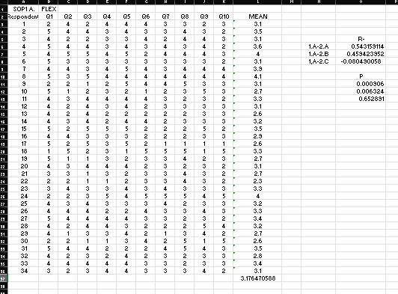

***Relationship Between the Level of Effectiveness and Acceptability of Onion (Allium Cepa) peel as an Alternative Paper based on flexibility.***

***Relationship Between the Level of Effectiveness and Acceptability of Onion (Allium Cepa) peel as an Alternative Paper based on durability.***

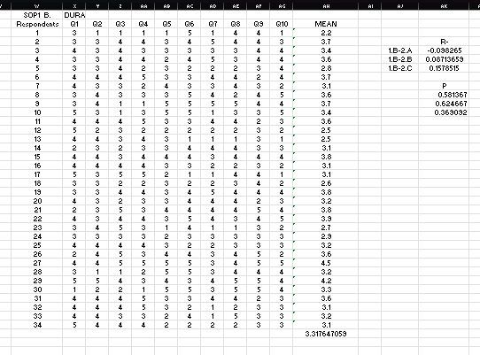

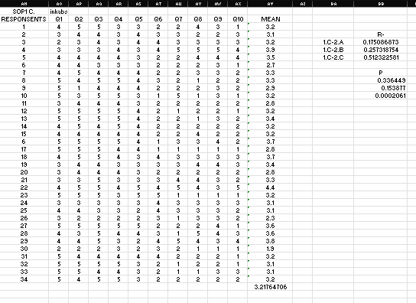

***Relationship Between the Level of Effectiveness and Acceptability of Onion (Allium Cepa) peel as an Alternative Paper based on ink absorption.***

**APPENDIX E**

**DOCUMENTATION**

**Documentation**

Firstly, the researchers boiled the 1 kilo of onion peel for about 60 minutes, then set aside it to the container.

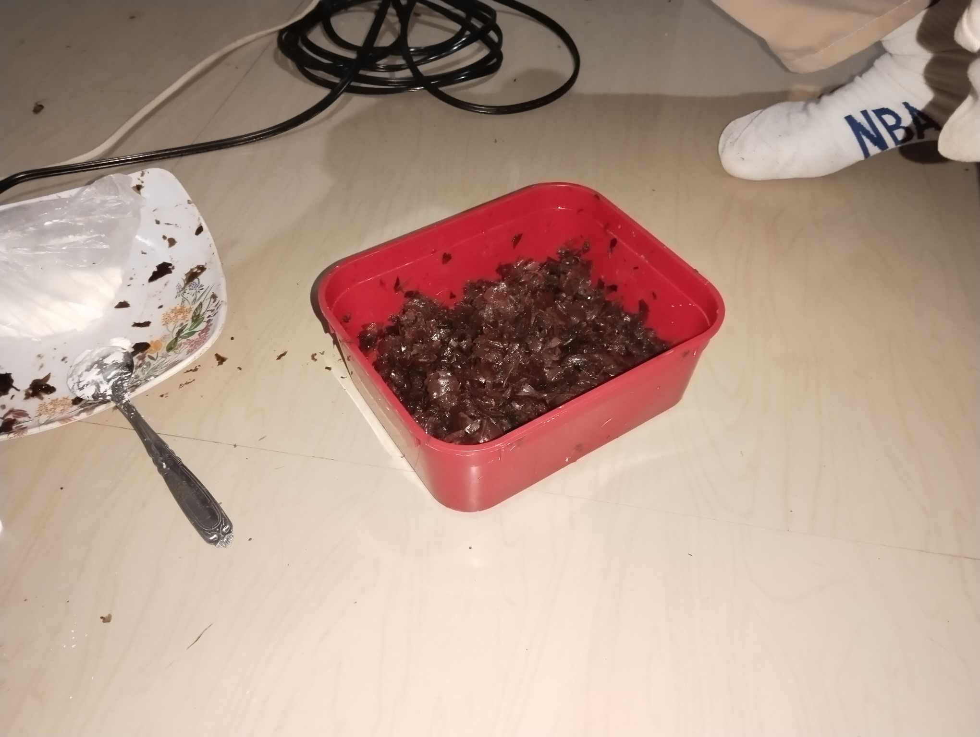

After boiling the onion peel, we put it to the blender for firming and to be smooth for molding it.

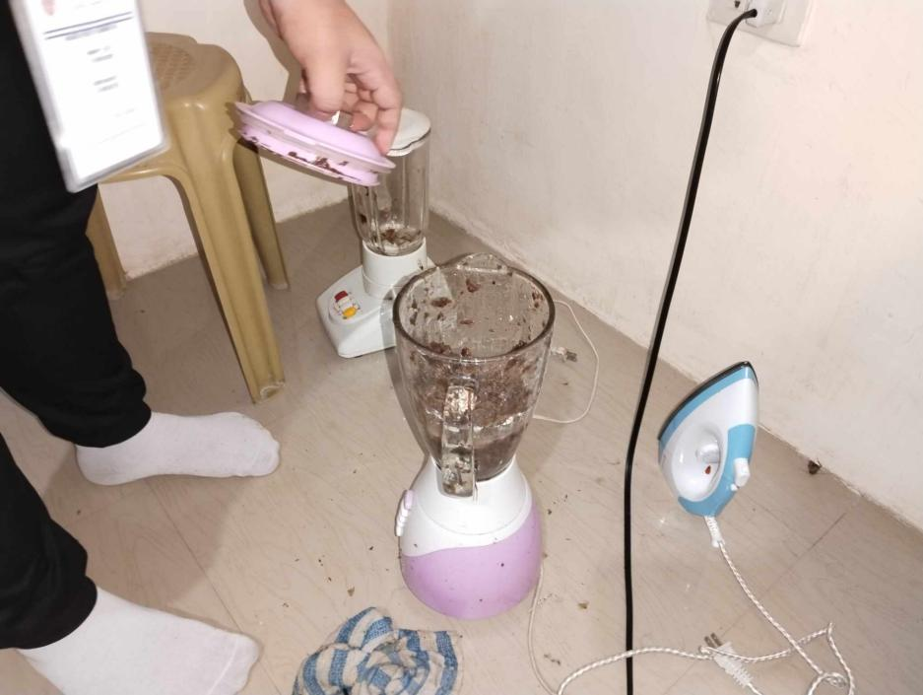

Then, researchers put the onion peel to the basin with water after blending. And start to mold it with mesh screen and will be used to drain remaining water, while restraining the solid inside.

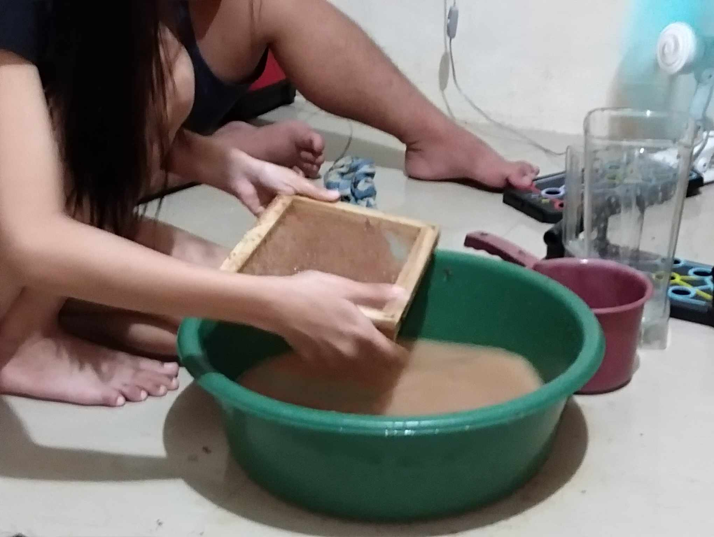

Using the sponge to gently press down the pulp, helping to remove more excess water.

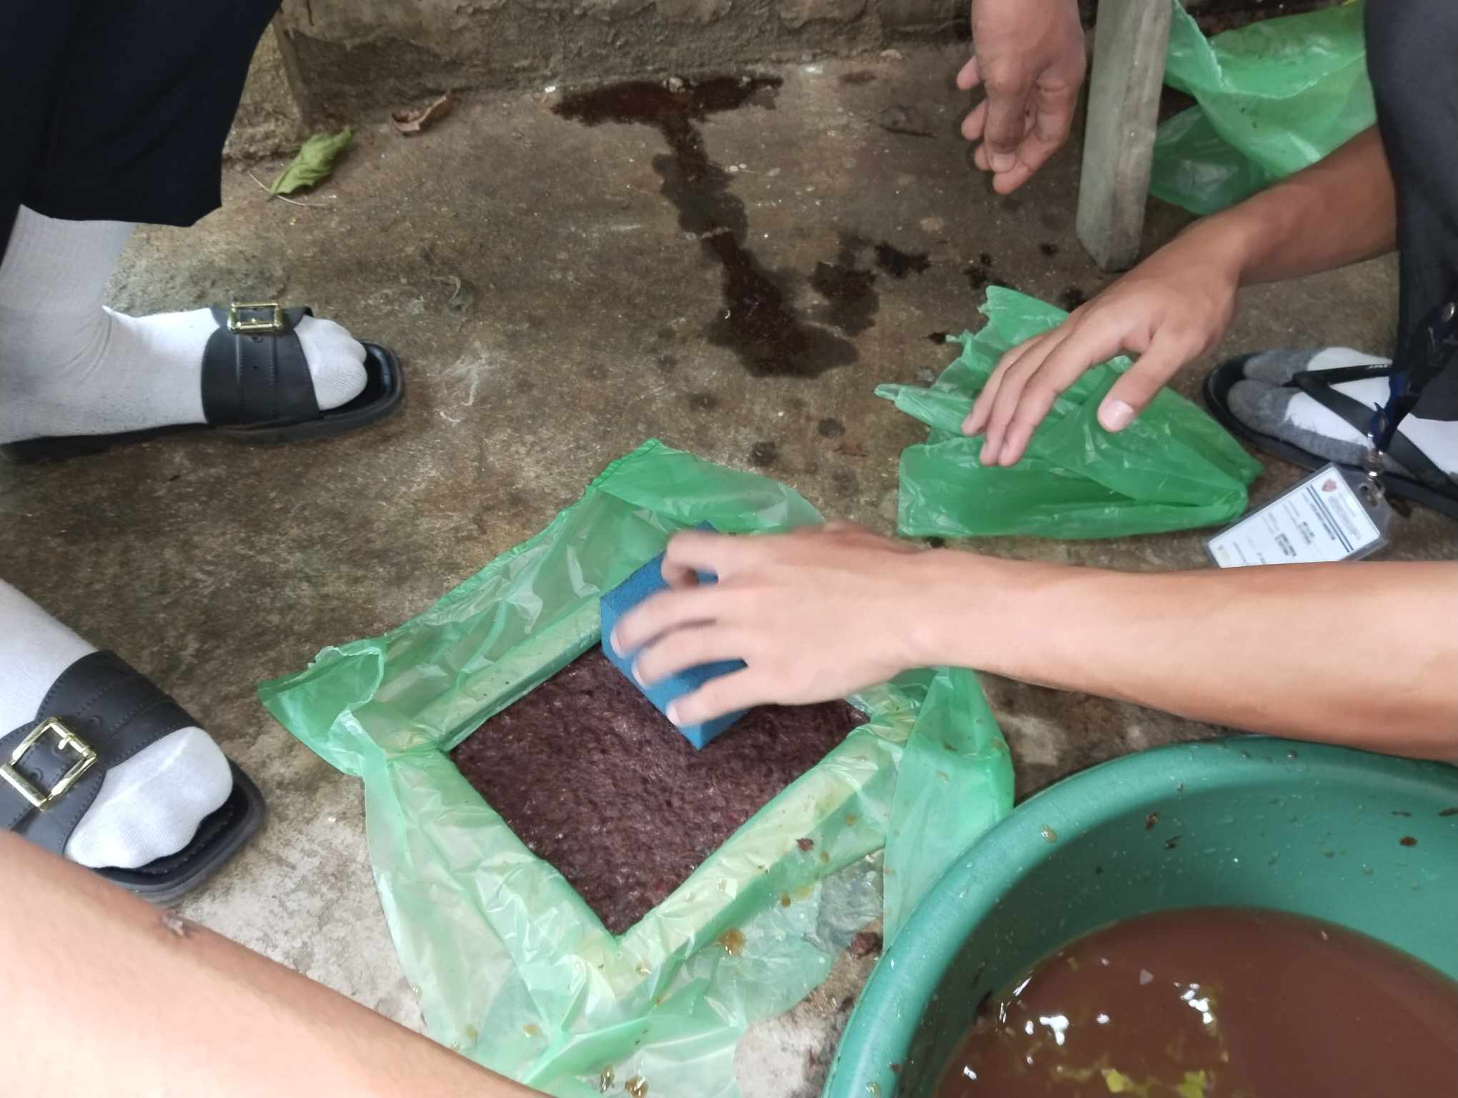

Leave the screen with the pulp in a well-ventilated area to dry, or speed up the

process by placing a dry cloth or towel on top and pressing gently. Once most of the

moisture is gone, carefully peel off the paper and leave it to dry completely. For a

smoother finish, lightly sand the surface or press it between heavy books.

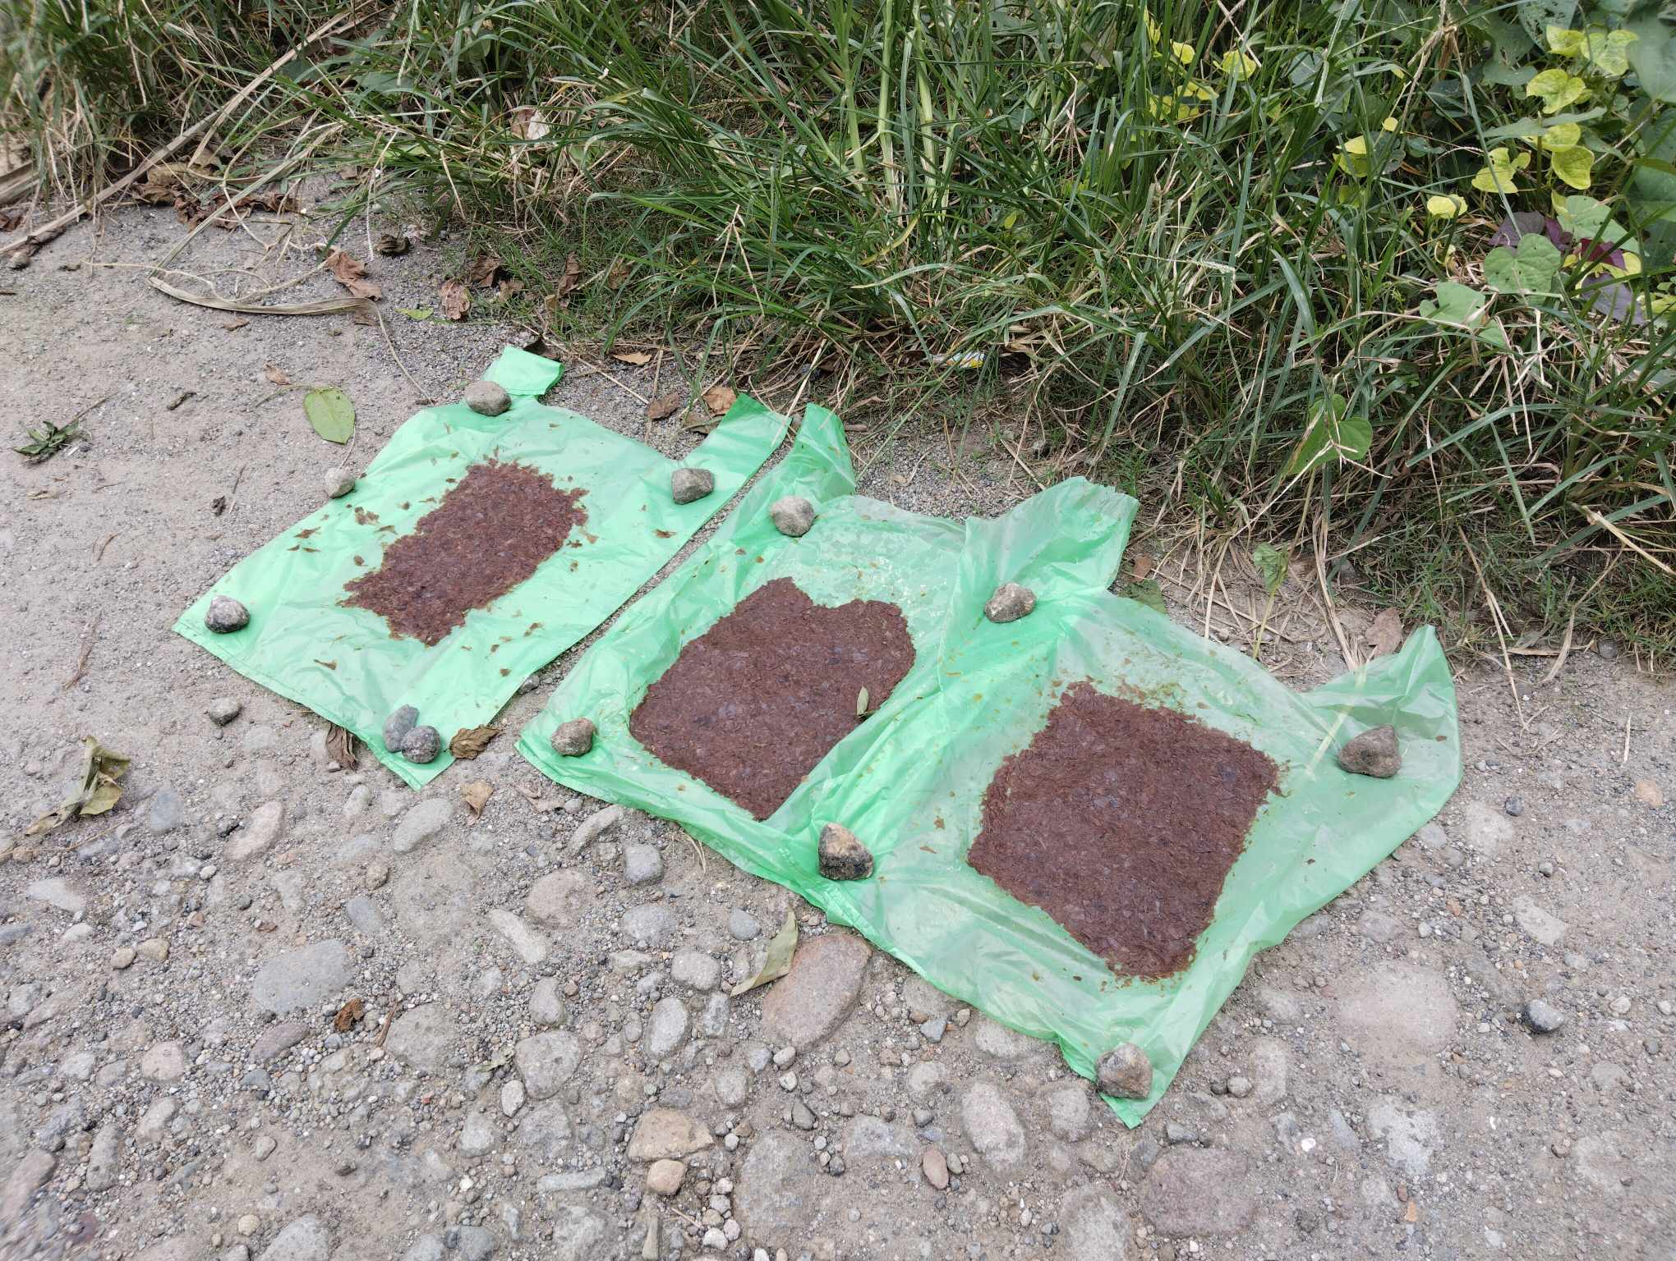

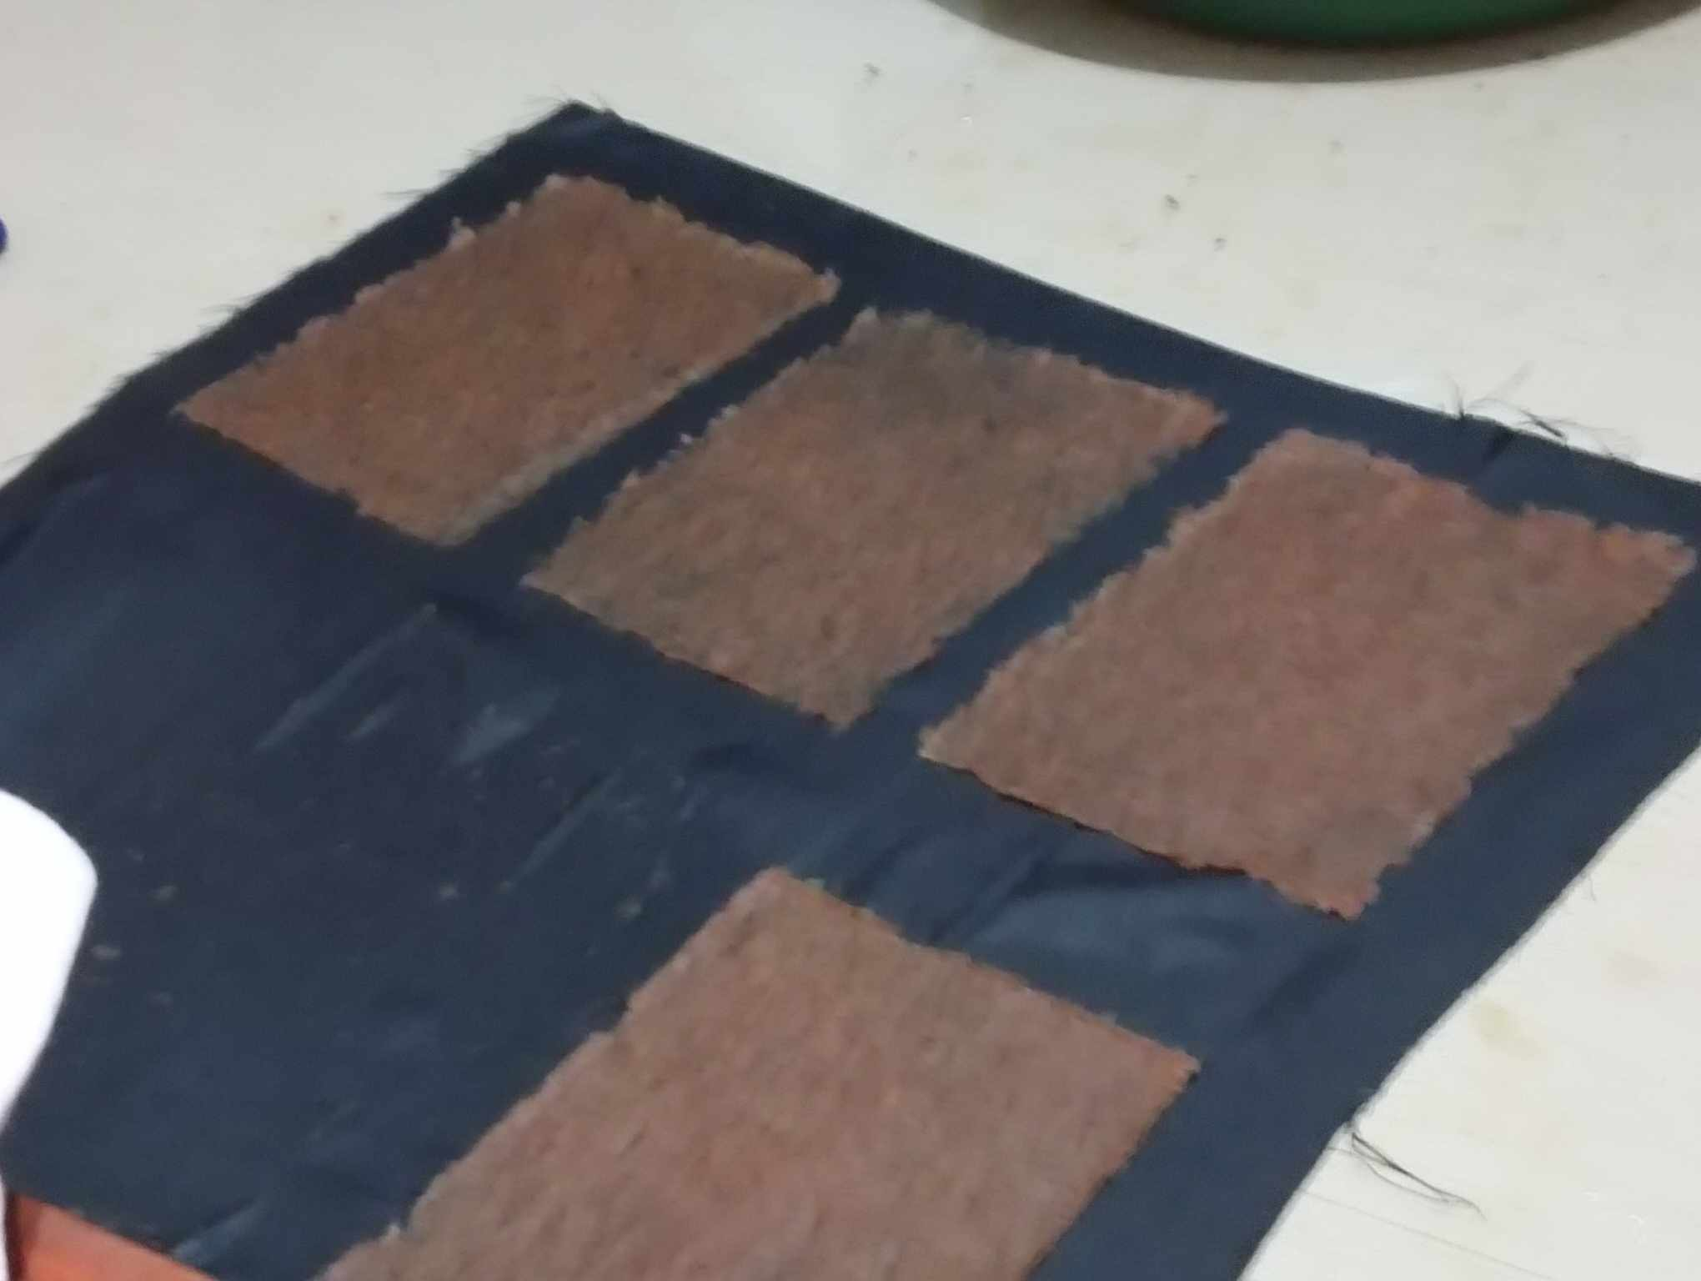

After, making the final product, the researchers then proceeded to conduct their survey questionnaires on the Grade - 11 students, STEM 4-AMBER.

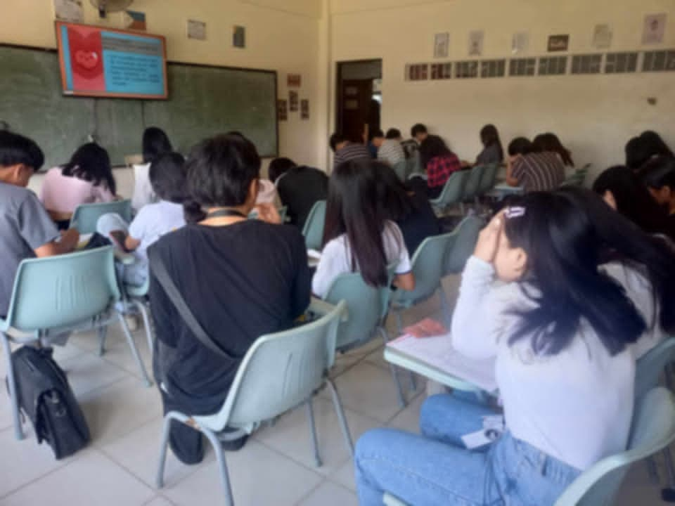

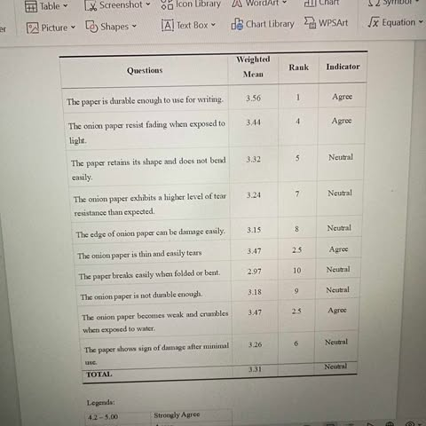After the researchers conducted their survey questionnaires, the researchers started to compute the data that they gathered and proceeded with the data interpretation thus finishing the chapter 4 and chapter 5

**APPENDIX F**

**CURRICULUM VITAE**

**JOSE MANUEL O. CHAN**



Fabricante St., South Centro, Sipocot, Camarines Sur

Contact No.: 09305237289

Email: [joemchan012707@gmail.com](mailto:joemchan012707@gmail.com)

Facebook: Joem Chan

|  |
| --- |
| **OBJECTIVE:**  As a student and an individual, my goal in doing research is to gain a deeper understanding of the world, improve my critical thinking, and find practical solutions to real-life problems. It helps me in school and in my personal life by developing skills like problem-solving, analysis and decision-making. |
| **PERSONAL BACKGROUND:**  **Date of Birth: January 27, 2007**  **Age: 17 years old**  **Religion: Roman Catholic**  **Civil Status: Single**  **Gender: Male**  **Citizenship: Filipino**  **Languages: Bikol, Tagalog, English**  **Height: 5’4**  **Weight: 53kg**  **Hair Color: Black**  **Father’s Name: Michael M. Chan**  **Mother’s Name: Juliet O. Chan** |
| **EDUCATIONAL ATTAINMENT:**  **Secondary: CENTRAL BICOL STATE UNIVERSITY OF AGRICULTURE**  **Coloy-coloy, Impig, Sipocot, Camarines Sur (2022-2023)**  **Elementary: SIPOCOT NORTH CENTRAL SCHOOL**  **Impig, Sipocot, Camarines Sur (20218-2019)** |
| **STRENGTH AND QUALIFICATION:**   * I’m creative and love using my artistic skill. I work hard, stay focused, and get things done on time. I also enjoy working with others and contributing to group success. |
| **RESEARCH UNDERTAKEN:**  **Impact Assessment on the Efficacy of the Covid-19 Protocols During the Nationwide Pandemic in Sipocot, Camarines Sur**  **Feminist Approach Criticism Disney’s Moana**  **Onion (*Allium Cepa*) Peel as an Alternative Paper** |
| **CHARACTER REFERENCES:**  **Ma Majella C. Nieva** |



**WENCY ANGELO B. PAZ**

Malubago, Sipocot Camarines Sur 4408

Contact No.: 09941795817

Email: [pazwencyangelo@gmail.com](mailto:pazwencyangelo@gmail.com)

Facebook: Wency Angelo Paz

|  |
| --- |
| **OBJECTIVE:**  As a student and an individual, research is about discovering and understanding. It's about going beyond what's already known and exploring the unknown My inherent curiosity is ignited by the desire to learn, propelling me towards profound understanding. |
| **PERSONAL BACKGROUND:**  **Date of Birth: February 8, 2007**  **Age: 17 years old**  **Religion: Roman Catholic**  **Civil Status: Single**  **Gender: Male**  **Citizenship: Filipino**  **Languages: Filipino, English**  **Height: 5’4**  **Weight: 78kg**  **Hair Color: Black**  **Father’s Name: N/A**  **Mother’s Name: Prescila Beldad** |
| **EDUCATIONAL ATTAINMENT:**  **Secondary: FELIX O. ALFELOR SR. FOUNDATION COLLEGE**  **San Juan Avenue, Sipocot Camarines Sur (2022-2023)**  **Elementary: KING THOMAS LEARNING ACADEMY INC**  **Malubago, Sipocot, Camrines Sur (2018-2019)** |
| **STRENGTH AND QUALIFICATION:**   * **Collaboration** * **Communications skills** * **Hardworking** * **Empathy** * **Time Management** |
| **RESEARCH UNDERTAKEN:**  Cognitive Approach Criticism: The Hows of Us directed by Cathy Garcia-Molina  Onion (*Allium Cepa*) Peel as an Alternative Paper |
| **CHARACTER REFERENCES:**  **Kristine Mae B. Paz**  **Ma Majella C. Nieva** |

**GABRIEL BRYAN PANUELOS**



Alteza, Sipocot, Camarines Sur.

Contact No.: 09197359533

Email: [gabrielbryanpanuelos@gmail.com](mailto:gabrielbryanpanuelos@gmail.com)

Facebook: Gabriel Bryan

|  |
| --- |
| **OBJECTIVE:**  To explore topics of interest, develop critical thinking, and apply knowledge for professional growth. |
| **PERSONAL BACKGROUND:**  **Date of Birth: May 14, 2007**  **Age: 17 years old**  **Religion: Roman Catholic**  **Civil Status: Single**  **Gender: Male**  **Citizenship: Filipino**  **Languages: Bikol, Tagalog, English**  **Height: 5’3**  **Weight: 46kg**  **Hair Color: Black**  **Father’s Name: N/A**  **Mother’s Name: Gerlie Rejano Panuelos** |
| **EDUCATIONAL ATTAINMENT:**  **Secondary: CENTRAL BICOL STATE UNIVERSITY OF AGRICULTURE**  **Coloy-coloy, Impig, Sipocot, Camarines Sur (2022-2023)**  **Elementary: SIPOCOT NORTH CENTRAL SCHOOL**  **Impig, Sipocot, Camarines Sur (20218-2019)** |
| **STRENGTH AND QUALIFICATION:**   * **Collaboration** * **Adaptability** * **Communications skills** * **Research Experience** * **Emotional Intelligence** |
| **RESEARCH UNDERTAKEN:**  **Philosophical Approach: Understanding The Zero Existence in Young Sheldon Season 6 Episode 4**  **Onion (*Allium Cepa*) Peel as an Alternative Paper** |
| **CHARACTER REFERENCES:**  **Ma Majella C. Nieva** |



**KRISJAN EIZER DE LA CRUZ**

Gaongan, Sipocot Camarines Sur 4408

Contact No.: 09187254727

Email: [delacruzkrisjan@gmail.com](mailto:delacruzkrisjan@gmail.com)

Facebook: Krisjan De La Cruz

|  |
| --- |
| **OBJECTIVE:**  To investigate relationships between variable and contribute to academic knowledge. |
| **PERSONAL BACKGROUND:**  **Date of Birth: January 3, 2007**  **Age: 18 years old**  **Religion: Christian Catholic**  **Civil Status: Single**  **Gender: Male**  **Citizenship: Filipino**  **Languages: Filipino, English**  **Height: 5’7**  **Weight: 53kg**  **Hair Color: Black**  **Father’s Name: N/A**  **Mother’s Name: Kris A. De la Cruz** |
| **EDUCATIONAL ATTAINMENT:**  **Secondary: SIPOCOT NATIONAL HIGH SCHOOL**  **Tara, Sipocot, Camarines Sur (2022-2023)**  **Elementary: GAONGAN ELEMENTARY SCHOOL**  **Gaongan, Sipocot, Camarines Sur (2018-2019)** |
| **STRENGTH AND QUALIFICATION:**   * **Time Management** * **Communication Skills** * **Strong Dedication** * **Teamwork Skills** * **Emotional Intelligence** |
| **RESEARCH UNDERTAKEN:**  **“Exploring Barbie Movie Directed by Greta Gerwig. A Qualitative Research Froam a Chauvinism Approach’’**  **Onion (*Allium Cepa*) Peel as an Alternative Paper** |
| **CHARACTER REFERENCES:**  **Ma Majella C. Nieva** |

**ALDRIN N. CHUMACERA**



Sooc, Lupi, Camarines Sur 4408

Contact No.: 09075381828

Email: [aldrinchumacera332@gmail.com](mailto:aldrinchumacera332@gmail.com)

Facebook: Aldrin Chumacera

|  |
| --- |
| **OBJECTIVE:**  To explore solutions for real-world issues, informing evidence-based decision-making. |
| **PERSONAL BACKGROUND:**  **Date of Birth: June 22, 2007**  **Age: 17 years old**  **Religion: Baptist**  **Civil Status: Single**  **Gender: Male**  **Citizenship: Filipino**  **Languages: Filipino, English**  **Height: 5’5**  **Weight: 51kg**  **Hair Color: Black**  **Father’s Name: Adolfo Chumacera**  **Mother’s Name: Gina Chumacera** |
| **EDUCATIONAL ATTAINMENT:**  **Secondary: VILLAZAR NATIONAL HIGH SCHOOL**  **North Villazar, Sipocot Camarines Sur (2022-2023)**  **Elementary: SOOC ELEMENTARY HIGH SCHOOL**  **Sooc, Lupi, Camarines Sur (2018-2019)** |
| **STRENGTH AND QUALIFICATION:**   * **Teamwork** * **Creative** * **Research Experience** * **Presentation Skills** |
| **RESEARCH UNDERTAKEN:**  **Feminist Approach Criticism Disney’s Moana**  **Onion (Allium Cepa) Peel as an Alternative Paper** |
| **CHARACTER REFERENCES:**  **Ma Majella C. Nieva** |

**ROSALINDA S. MARASIGAN**



Salanda, Sipocot, Camrines Sur

Contact No.: 09911138867

Email: [ayamarosa1006@gmail.com](mailto:ayamarosa1006@gmail.com)

Facebook: Rosalinda Marasigan

|  |
| --- |
| **OBJECTIVE:**  To me, the main objective of research as a student is to gain knowledge, develop our critical thinking, and improve our problem-solving skill**s.** Also, as an individual it helps me to broaden my perspectives, discover new ideas and problem to solve that seeks truth and understanding. Research helps me become a more informed, critically thinking and capable of contributing positively to society |
| **PERSONAL BACKGROUND:**  **Date of Birth: October 6, 2007**  **Age: 17 years old**  **Religion: Roman Catholic**  **Civil Status: Single**  **Gender: Female**  **Citizenship: Filipino**  **Languages: Filipino, English**  **Height: 5’3**  **Weight: 49kg**  **Hair Color: Black**  **Father’s Name: Liberato Cornejo Marasigan**  **Mother’s Name: Angelita Sebuc Marasigan** |
| **EDUCATIONAL ATTAINMENT:**  **Secondary: VILLAZAR NATIONAL HIGH SCHOOL**  **North Villazar, Sipocot Camarines Sur (2022-2023)**  **Elementary: VILLAZAR NATIONAL ELEMENTARY SCHOOL**  **North Villazar, Sipocot Camarines Sur (2018-2019)** |
| **STRENGTH AND QUALIFICATION:**   * I'm good at thinking critically communicating and researching. I work well with others, motivate myself and understand emotions. |
| **RESEARCH UNDERTAKEN:**  **Philosophical Approach: Understanding The Zero Existence in Young Sheldon Season 6 Episode 4**  **Onion (*Allium Cepa*) Peel as an Alternative Paper** |
| **CHARACTER REFERENCES:**  **Ma Majella C. Nieva** |

**QUEENCY LEE ADOPTANTE**



Malubago, Sipocot, Camarines Sur

Contact No.: 09999639774

Email: [aqueencylee@gmail.com](mailto:aqueencylee@gmail.com)

Facebook: Queency Lee

|  |
| --- |
| **OBJECTIVE:**  As a student and an individual, my main goal is to dig deeper the understanding of every worth of the entire world. To develop more efficient solution to every problem. To improve and discover more that helps me seek and know about all. Lastly, developing these gives me knowledge and growth. |
| **PERSONAL BACKGROUND:**  **Date of Birth: November 21, 2006**  **Age: 18 years old**  **Religion: Christian Catholic**  **Civil Status: Single**  **Gender: Female**  **Citizenship: Filipino**  **Languages: Bikol, Filipino, English**  **Height: 5’4**  **Weight: 40kg**  **Hair Color: Black**  **Father’s Name: Nilo Adoptante**  **Mother’s Name: Lily Adoptante** |
| **EDUCATIONAL ATTAINMENT:**  **Secondary: SIPOCOT NATIONAL HIGH SCHOOL**  **Tara, Sipocot, Camarines Sur (2022-2023)**  **Elementary: DEL CARMEN ELEMENTARY SCHOOL**  **Del Carmen, Lupi, Camarines Sur (2018-2019)** |
| **STRENGTH AND QUALIFICATION:**   * I am doing my best in every situation, using critical thinking to get things done and solved. I am good at communication with others, and doing my task that are given to me. |
| **RESEARCH UNDERTAKEN:**  **Sociological Approach “Elemental” by Peter Sohn**  **Onion (*Allium Cepa*) Peel as an Alternative Paper** |
| **CHARACTER REFERENCES:**  **Ma Majella C. Nieva** |